Meet our Board Members.
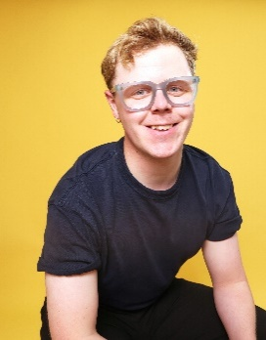
Tom Ryalls.

Tom is a writer and cultural organiser. He founded BAP! to interrogate the relationship between creativity and wealth redistribution - working with companies across the country on their fundraising, business planning, and campaigning to affect policy. He is the chair of Grey-eye, a trustee of Unlimited, and the Deputy Chair of the Disability Advisory Committee of Arts Council England.
In 2024 he was named in the Disability Power 100, and in 2025 became a Clore Fellow. In his writing practice he often makes very camp shows through a Marxist lens, entertaining and interrogating how we might change who gets to imagine the future. Tom was diagnosed with epilepsy when he was 8 and speaks publicly about how we support young people with epilepsy.

Lisa Ogun’
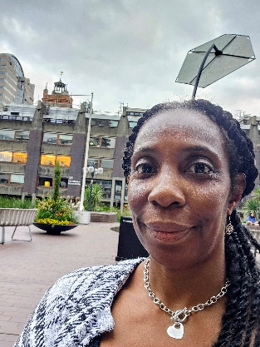
Lisa Ogun’ is a disabled Black-British multi-disciplined creative, with a focus on writing, performance for theatre, especially with marginalised communities and young people. She is specialised in headphone Verbatim Theatre, used to highlight stories from displaced communities. Having acquired degrees in Performance: Dance from University of London and Applied Theatre from (now Royal) Central School for Speech & Drama, she intertwines both to shape her creative explorations and collaborations. Additionally, with an African-Caribbean heritage, and experiences of homelessness and D.V., she uses her culture and experiences to inform her practices, address injustices and raise societal awareness.
She currently works with a broad range of charities involving arts and homelessness, and women and arts empowerment.

Robin Cantrill-Fenwick.
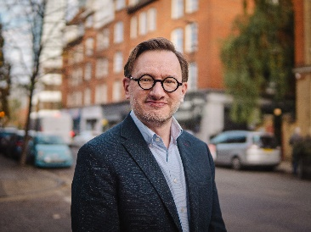
Robin Cantrill-Fenwick is Chief Executive of Baker Richards, the employee-owned consultancy and software provider specialising in earned income strategy and audience development for the cultural sector, and of Arts Professional.
For over two decades, he has used data and digital systems to transform organisations across multiple sectors, holding executive leadership roles and advising performing arts organisations and visitor attractions on strategy, marketing, audience development and operations. Previously Deputy Executive Director of Mercury Theatre Colchester, he has also led digital transformation at the National Trust, The Royal Society and the University of Westminster.

Dr Hannah Barham-Brown.
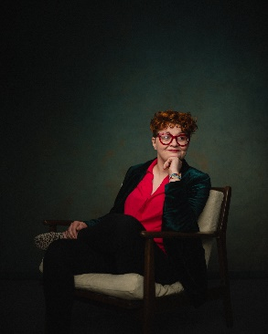
Dr Hannah Barham-Brown (she/her) is a GP in Scotland, working to create Gender Services for NHS Tayside, and is the Equity, Diversity and Inclusion Lecturer at University of Dundee School of Medicine. She is a Governor of the Motability Foundation, and former Deputy Leader of the UK Women’s Equality Party.
An internationally acclaimed speaker, Hannah is regularly commissioned to speak and consult on diversity, sexuality, and disability, having given two TEDx talks (TEDxNHS and TEDxExeter) on the need for diversity in employment.
Before studying postgraduate medicine, Hannah graduated from Durham University with BA Hons in Combined Arts, and from Northumbria University with BSc Hons in Paediatric Nursing. Hannah has been named as one of the Health Service Journal’s 100 Most Influential People in Health, as well as named on the Shaw Trust’s 2018, 2019 and 2020 ‘Power Lists’ – making her one of the 100 most Influential Disabled People in the UK.

Deborah Rees.
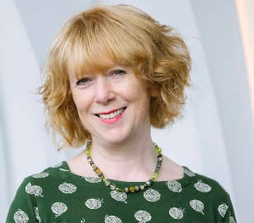
Deborah has over twenty years Chief Executive experience managing theatres and arts centres, and until recently was Director at Cast, Doncaster where she led the organisation for nine years. Prior to that Deborah was Director of The Roses Theatre in Tewkesbury for 11 years. Deborah now provides independent consultancy, interim executive leadership and project support across the arts and cultural sector.
She is a Fellow of the Royal Society of Arts and is also vice chair of Scala, Worcester's new arts centre, which is due to open in January 2027.

Nathan Crossan-Smith.
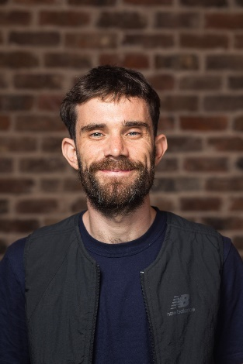
Nathan directs work across theatre, dance, immersive projects and opera as well as leading lyricism projects in prisons. He has directed for Liverpool Everyman, Orange Tree, Audible, LAMDA, Aurora Orchestra, NYT, Grey-eye, National Theatre Learning and Southbank Centre and led projects for Barbican, National Theatre Wales and 20 Stories High. He is Co-Director for Hydrocracker and a Trustee for Grey-eye. He trained at LAMDA, National Theatre Studio and Royal Ballet & Opera.
End of document.

Anthony Lee.
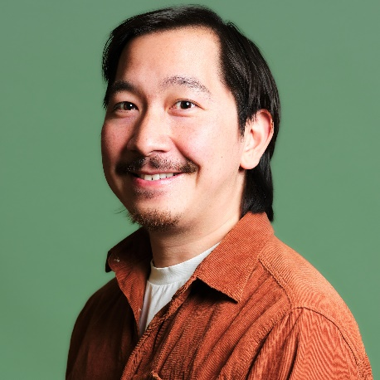
Anthony Lee is a marketing and project manager working in music, arts, and entertainment. With experiences across grassroots, national, and global organisations including The Royal Shakespeare Company, AWAL, BMG, Young Vic, and Sony Music.
His work focuses on developing holistic strategies, executing creative campaigns, and curating audience activations and as Marketing Manager at Nordoff and Robbins, the UK's largest music therapy charity he utilises these skills across events, partnership activity, and awareness campaigns.
Anthony is passionate about opportunities and demystifying the creative industries. He is a core member of ESEA Music, a growing community advancing the representation of East and Southeast Asians across the industry, a mentor, and is on the EDI panels of several organisations pushing for positive change.
As well as serving as a board member for Graeae Theatre Company, he is on the board of Manchester-based Brighter Sound, and the Independent Cinema Office.

