**Self-Raising**

**Easy Read Synopsis**

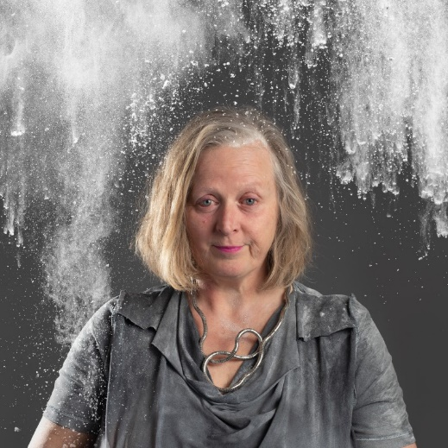

This is **Jenny Sealey.**

She is the Artistic Director

of Graeae Theatre Company.

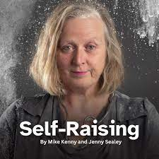

This play is called **Self-Raising.**



**Jenny** has written the **story.**



**Jenny** is also **acting** in the play.



This is **Ali Gordon.**

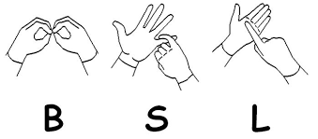

Ali is **signing** the performance

in **British Sign Language.**

The play is about **Jenny**

**growing up** as a young Deaf person.



The play is about **secrets.**



The play

is about **family.**

**Jenny** tells her story using

**family photos** and bags of **flour.**