**Self-Raising Content Notes - About the Performance**

Self-Raising is performed at the Queendome, in the Pleasance Dome, pictured below:

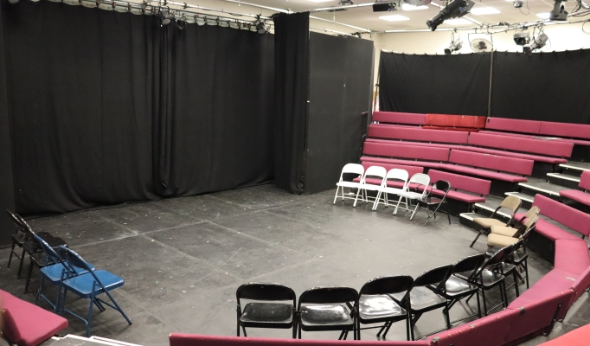

* The show is one-hour long.
* It is performed in a relaxed environment, so you can leave and return to the space.
* The actor will hand out bags of flour to the audience. They contain real flour. The loose flour is gluten-free.
* You might be asked to hold one of the flour bags and there may be some eye contact / audience participation if you sit in the front rows.
* During the show there will be lighting changes, projections on a screen, recorded music and sound effects.
* The theatre has 5 rows of seats in a horseshoe shape. The space can hold up to 130 people.