**Self-Raising Content Notes - About the Performance**

Self-Raising is performed at the Queendome, in the Pleasance Dome, pictured below:

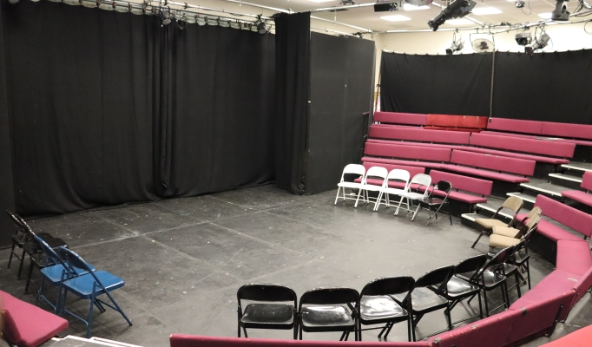

ALT TEXT: An image of a theatre studio. A black curtain hangs across the back wall and the side wall of the room. The stage area is a black floor and around this, the seating curves in a horseshoe shape. There are black folding chairs in the front row and behind these, four tiers of red bench-style seats with red cushioned seats and backs curve around. The seating is raked. There are steps from the back row down to the stage on both sides.

There are some theatre lights pointed at the stage area.

The show is one hour long.

It is performed in a relaxed environment, so you can leave and return to the space.

The actor will hand out bags of flour to the audience. They contain real flour. The loose flour is gluten-free.

You might be asked to hold one of the flour bags and there may be some eye contact or audience participation if you sit in the front rows.

During the show there will be lighting changes, projections on a screen, recorded music and sound effects.

The theatre has 5 rows of seats in a horseshoe shape. The space can hold up to 130 people.