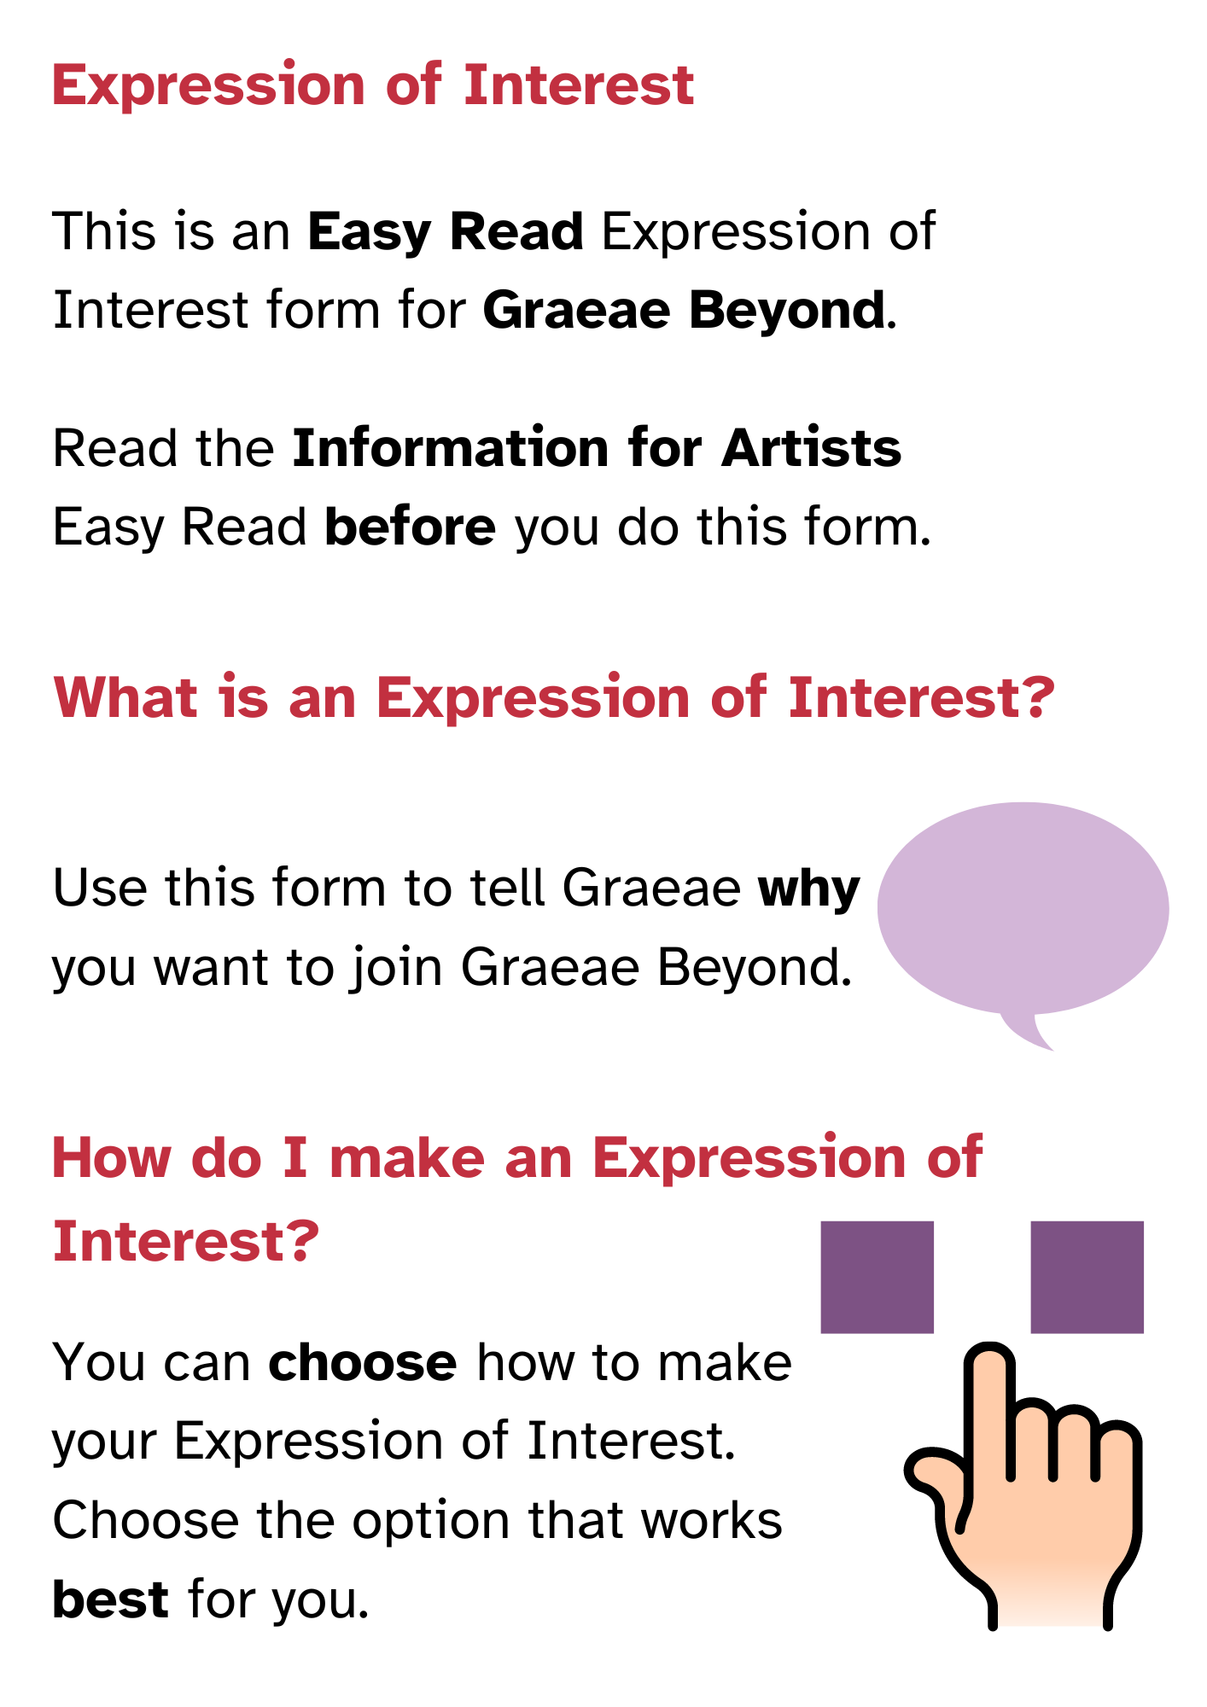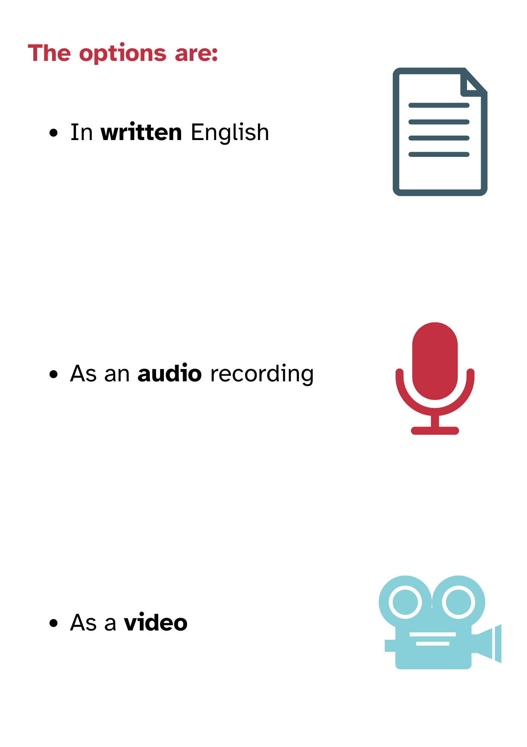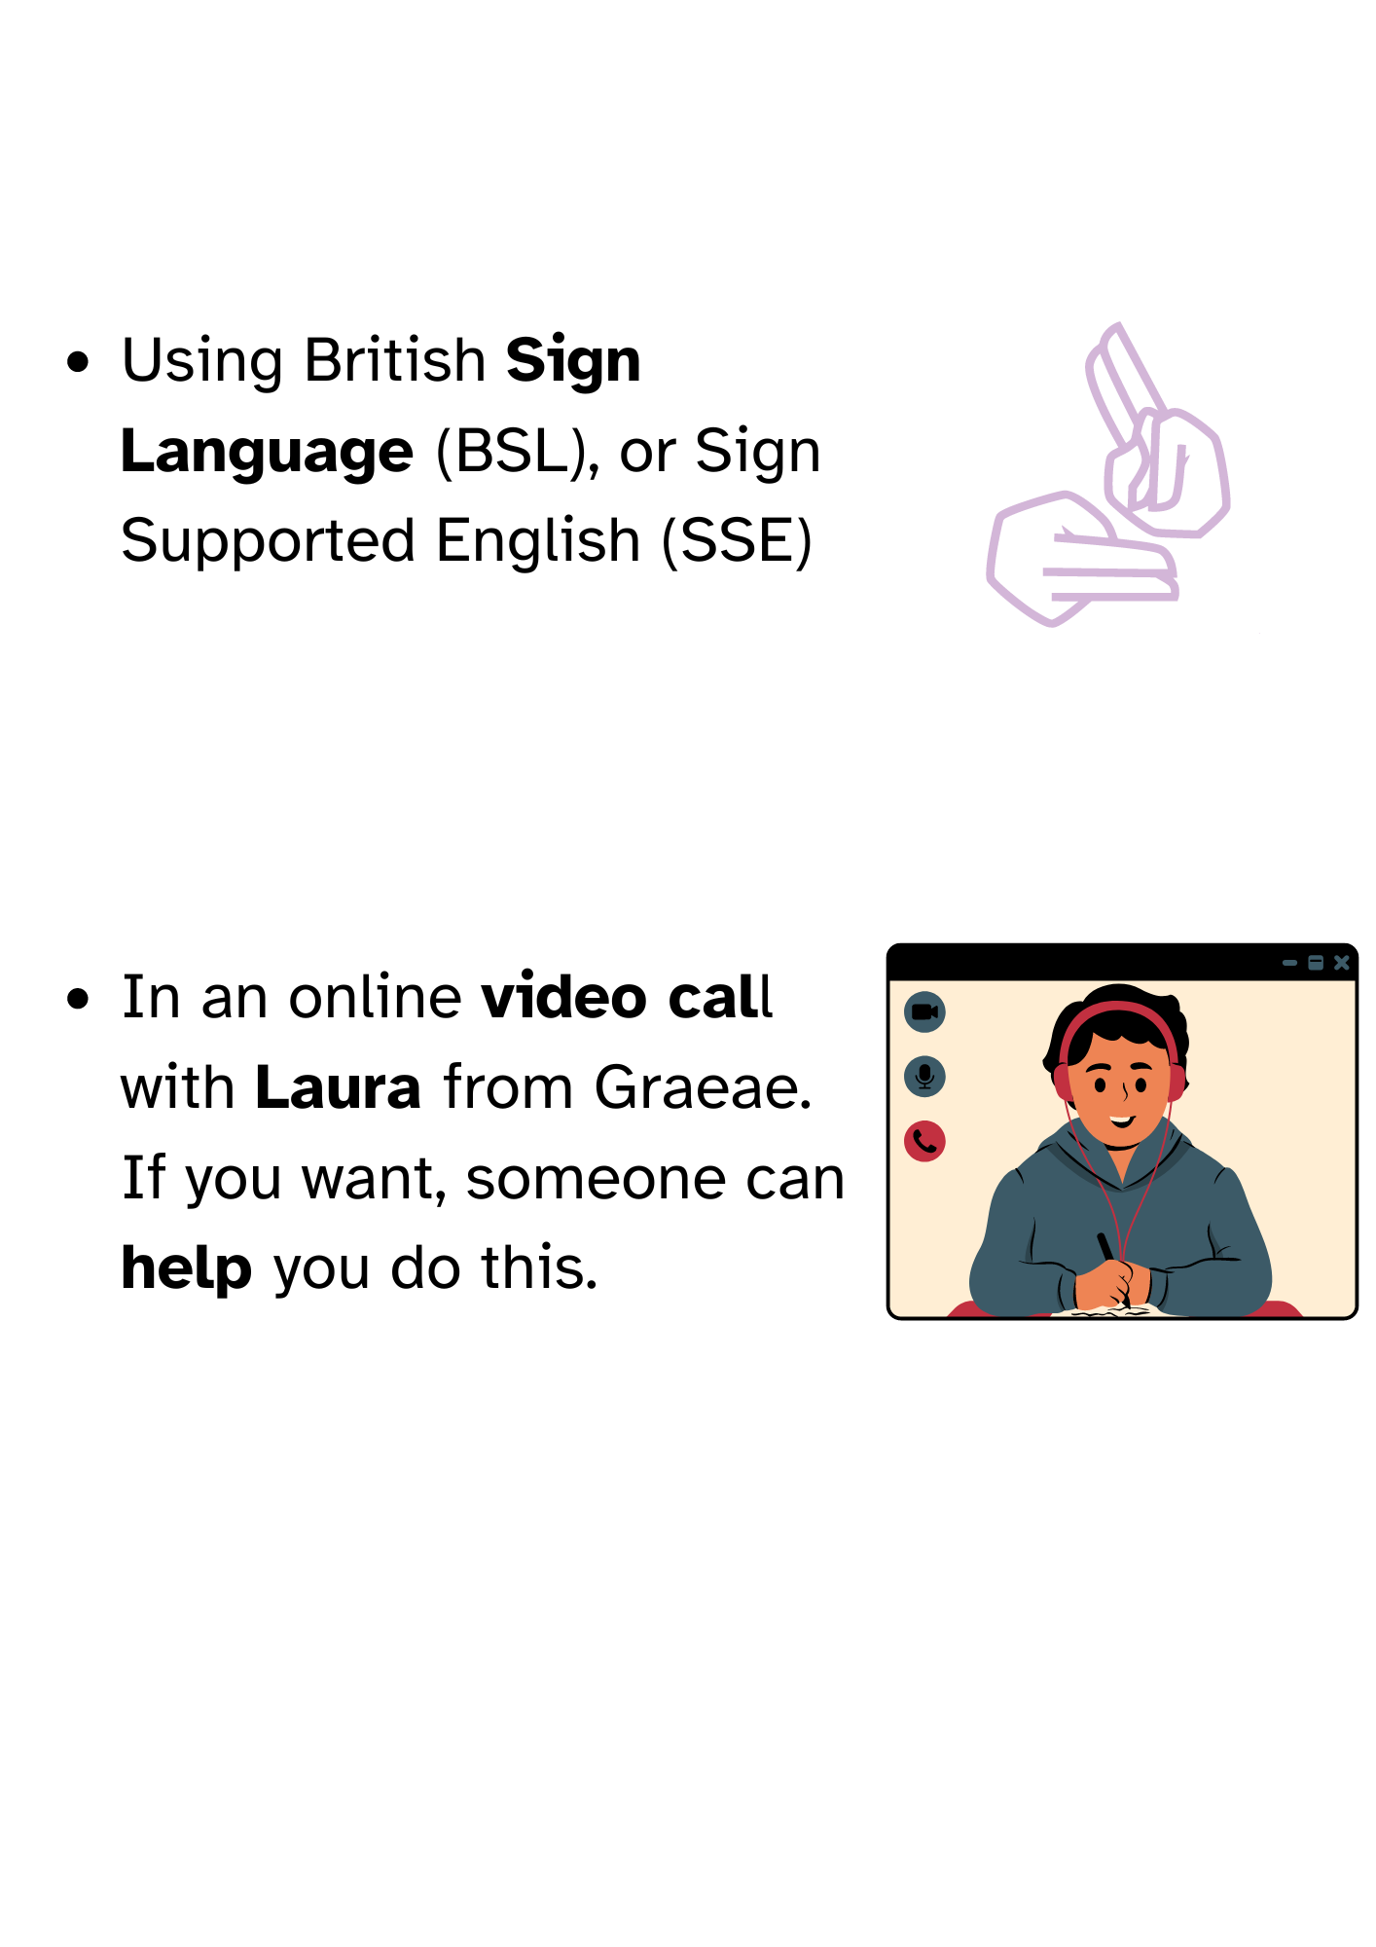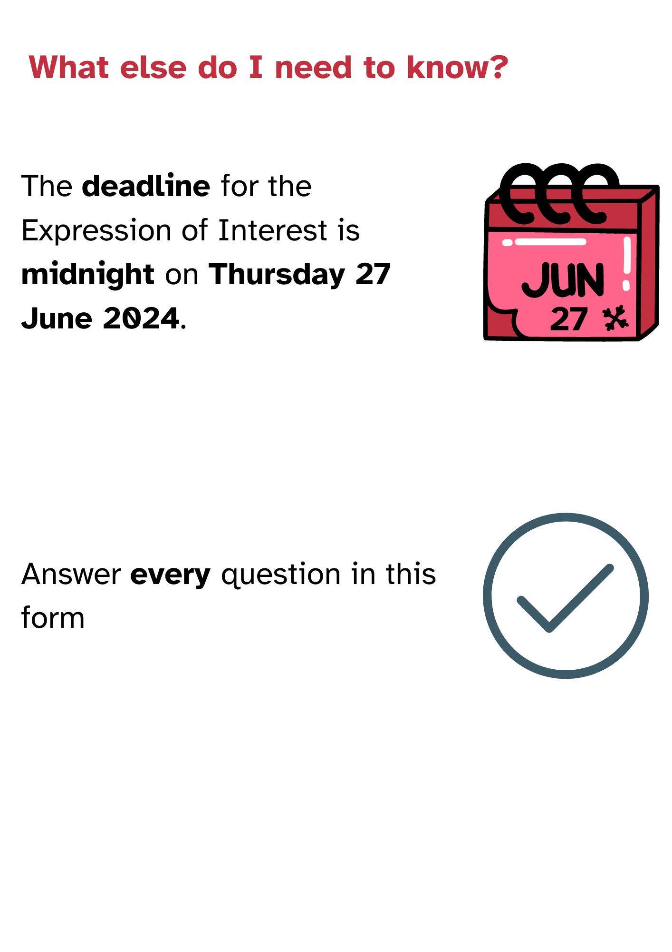

**About You**

**First Name(s):** **Surname:**

**Pronouns:** she/her he/himthey/themother:_________

**Full Address:**

**Landline: Mobile:**

**Email:**

How do want Graeae to contact you is not listed, **add** it here:

Text/SMS   Phone Call

 Email   Zoom

 Whatsapp  Skype

If how you want Graeae to contact you is not listed, **add** it here:

Which theatre is **closest** to your home?



Cast in Doncaster



Derby Theatre in Derby



Everyman Theatre in Liverpool



Hull Truck Theatre in Hull



Mercury Theatre in Colchester



Nottingham Playhouse in Nottingham



Octagon Theatre in Bolton

Have you **worked** with these theatres **before**? Yes  No

If **yes**, tell us **when** and **how** you **worked** with these theatres:

Your Work

Tell us which type of theatre artist you are.

You can choose more than one.

 Performer   Writer

Designer  Director

 Technician   Other:

Tell us about **theatre** or **art** you have made, or been part of, in the **past**.

Tell us which parts of making theatre you **enjoy**, and why.

Tell us which parts of making theatre you would like to **learn** **more** about.

Think of a **creative idea** you want to make happen.

Tell us about this **idea**.

You can use **photos** and **images** if you want to.

Tell us how **Graeae Beyond** can **help** you make your idea happen.

__________________________________________________

**This section is** **optional**

You **do not** have to answer this question.

Only answer this question if you **want** to.

Has anything ever **stopped** you from making theatre?

If **yes**, tell us about it here, if you want to.

Your Career

Think about your career as a theatre artist.

What do you want to **achieve**?

Tell us how **Graeae Beyond** can help you **achieve** this.

Which things do you need **help** with?

You can choose **more** than **one**.

 

Producing  Marketing

 

Managing Money  Finding places to show work



Connecting with artists and theatres

If you need help with something that is not on the list, add it here:

**Declaration**

I confirm that all the **information** I have given is **correct**.

Yes or No

Sign your name here: ________________________________

Would you like your **contact details shared** with the theatres involved with Graeae Beyond?

Yes or No

If yes, please select the details you will be happy to share:

 

Phone Number  Email Address



Full Address

If you want more information about what Graeae will do with your personal details, visit:

<https://graeae.org/policies/privacy-policy/>



**Manishta’s** **email** is: [manishta@graeae.org](mailto:manishta@graeae.org)

