Graeae, Cast, Hull Truck Theatre Nottingham Playhouse, Octagon, Shakespeare North, Liverpool Everyman, Derby Theatre, The Mercury
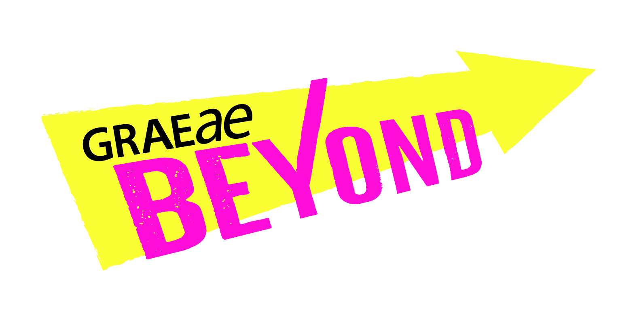

Expression of Interest form (EOI form)

General Information
Please ensure you have accessed our Information for Artists.

We welcome Expressions of Interest in any format accessible to you including written English, an audio recording, video (BSL/SSE/spoken) or via a meeting. If you require access support in completing your Expression of Interest please let us know.

If you would like to contact us for more information before submitting your Expression of Interest, please contact Laura Guthrie, Artist Development Manager, laura@graeae.org

Criteria
By submitting your Expression of Interest (EOI), you confirm that you:
- You are over 18 years old
- You are based in England and live, work or have a deep connection with any of the areas where our partner theatres are based: Bolton, Prescott, Nottingham, Derby, Hull, Liverpool, Doncaster, or Colchester (Essex)
- You identify as Deaf, disabled or neurodivergent & have experienced barriers to the industry and ways of developing your creative career.
- You need to have a record of commitment to creating live performance (online or in person) as a performer, writer, director, producer, designer or technician.

Guidelines
- Complete responses to all questions outlined below in this form. Incomplete responses to Expressions of Interest (EOI) could delay our response, due to the high volume of applications we receive.

- Send both your Expression of Interest (EOI) and confidential Equal Opportunity & Monitoring information to manishta@graeae.org

- We will send you a confirmation email within 1 week of receiving your Expression of Interest (EOI).

- Here is a timeline to the application process:

- Submit your EOI form by midnight 27th June 2024.
- We will inform all shortlisted artists by 22nd July 2024
- We will arrange informal interviews with shortlisted artists between
5th & 30th August 2024. More details will be sent at a later stage
- The programme will formally start in September

Your Expression of Interest (EOI)

- About you
First Name/s: Surname:

Pronouns:

Full Address:

Landline:

Mobile:

Email:

Please select your preferred means of communication(s):
Telephone:
SMS:
Email:
Skype (include your username):
Zoom:
WhatsApp:
Other (specify):

Please indicate which partner venue/s you would like to be connected to through the Beyond programme. Tick as many as are appropriate.
North: Cast in Doncaster
North: Hull Truck Theatre in Hull
North West: Shakespeare North Playhouse in Prescot
North West: Everyman Theatre in Liverpool
North West: Octagon Theatre, in Bolton
East Midlands: Derby Theatre in Derby
East Midlands: Nottingham Playhouse in Nottingham
East of England: The Mercury Theatre in Colchester

In 150- 200 words, Please tell us why you have chosen your venue/s.

- Your Statement of Interest
- In 250- 300 words, please tell us about yourself and how you would like to benefit from BEYOND. Please include a summary of your artistic practice to date and your specific interests or areas of work.

- In 200 - 250 words share an idea you would like BEYOND to support you in taking further. You can include photos/images also.

- Please describe any access-related or other barriers you have faced which may have prevented you from fully exploring your artistic practice.

- Your career
- In approximately 250 words please tell us where you would like BEYOND to take you in your career.

- Are there any areas that you feel you need particular support in such as producing, marketing, financial management, networking, showcasing opportunities etc.?

- Declarations
- I confirm that all the information I have supplied on this form is correct and meets the criteria for eligibility.
- We will be sharing your EOI form with the Beyond partner venues. However, your contact details will not be shared until you are on the programme and have a connection with a Beyond partner venue.
- To find out more, please see Graeae’s complete Privacy Policy here: https://graeae.org/privacy-policy/. I confirm to Graeae storing my information in line with data protection legislation and privacy policy:

Signed / Your Name:

Thank you!

Please send your Expression of Interest and Equal Opportunities & Monitoring information to:
Manishta Sunnia, Artist Development Coordinator

manishta@graeae.org

