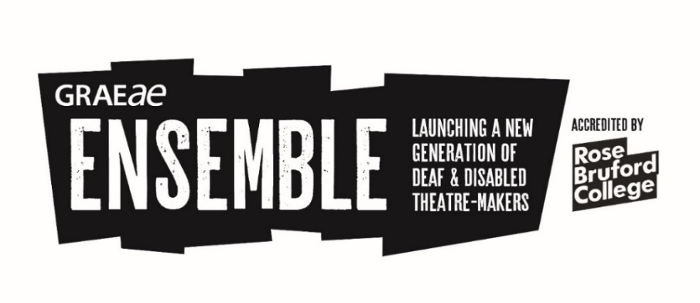
Ensemble: Certificate of Higher Education
Theatre Making and Leadership

Applications now open
for course commencing September 2021!
World class drama training
Graeae Ensemble was established in 2015 to deliver a radical alternative to traditional drama training. Ensemble’s driving mission is to serve new generations of diverse Deaf and disabled talent to thrive as equals in the UK’s theatre industry, on stage and off.

Graeae’s Ensemble Cert HE course in Theatre Making and Leadership is a level 4 course in partnership with Rose Bruford College, in association with Royal Central School of Speech and Drama, LAMDA and RADA.

To view our equal opportunities and dignity at work policies please visit: www.graeae.org
To access in alternative formats please contact lizzy@graeae.org

About this course

The course offers unparalleled access to industry and training expertise whilst artists can develop their skills in a fully accessible training environment.
Graeae Ensemble is a pioneering Cert HE in Theatre Making and Leadership accredited by Rose Bruford College and is proudly disabled-led. The course is delivered by highly skilled practitioners and visionary artists and supported by mentors working in the theatre industry, TV, film and radio.
By undertaking this course, you will develop skills in acting, performance and accessible theatre making which forms part of the course’s final devising process culminating in a public performance in 2022.
The is a level 4 course with 120 credits.
View the full Programme Specification here, these are delivered across the 4 modules:

- Skills of the Theatre Maker
- Approaches to Performance
- Think, Reflect, Share
- Platform (rehearsals and production)

View the full Module Specifications here, they include units in:

- Acting Techniques
- Approaches to Performance
- Theatre for Social Change
- Approaches to Text
- Directing
- Workshop Design and Facilitation
- Devising

Course Dates

The course is traditionally run from Graeae’s fully accessible building in Hoxton and at Rose Bruford College in Sidcup as well as at the venues of our partner drama schools.
The course also offers mentoring, regular networking opportunities, free theatre tickets and ongoing support from Graeae beyond the completion of the course.
Discover week*
Monday 6 September – Friday 10 September 2021
10am – 3pm (with lunch and comfort breaks)
Delivered onsite at Graeae and Rose Bruford College (London and Kent) - TBC
This course could be delivered online to ensure a covid-safe environment for those who may be still shielding or vulnerable under the pandemic*
Ensemble: Cert HE in Theatre Making and Leadership
22 November 2021 – 31 July 2022
Full time
Graeae acknowledges the importance of face to face learning and collaboration whilst also embracing the benefits of digital learning, both to ensure a high standard of professional drama training.
In 2021, this course could be delivered online to provide a covid-safe environment for those who may be still shielding or made vulnerable under the pandemic.
In 2022, this course is set to be delivered as face to face learning at Graeae and Rose Bruford College (London and Kent). Approximately 20% of this course could be delivered online including discussion-based tutorials, research and reading and 1:1 industry mentoring.

Can I apply?
To be considered for this course, your application will demonstrate that you meet the following criteria:
- Be aged between 17 and 29 (as of 10 September 2021)
- Be passionate about theatre
- Be ready to take on new challenges and move outside comfort zones (access requirements will be met at all times to ensure a level playing field)
- Be committed to working as a member of a performance ensemble
- Be Deaf and/or disabled, or have faced barriers to formal training, further education and/or employment due to access needs not being met
- Be available to train full-time from January – July 2022
To be considered for this course we ask you to make an initial application. The aim of the application is to learn more about you, the actor/theatre maker you wish to become and how the Ensemble training could benefit and support your ambitions.
If your application is selected, we will ask you to attend the Discover week. Discover is a one-week short course of ‘taster’ sessions, plus an audition. The audition process is warmly facilitated in a supportive environment. Our guidance is offered in advance of the Discover week if you would like help to choose and prepare your audition piece.

How much are the course fees?
This is an accredited course in partnership with Rose Bruford College and in association with LAMDA, RADA and the Royal Central School of Speech and Drama.
The fee for this course is £9,250. This includes all training, course materials, theatre visits, access to Graeae’s library of plays and Rose Bruford College’s learning resources, and 1:1 mentoring.
Student Loans
Providing you have not had a student loan before, artists on this course will be eligible to apply for a student loan through the national Student Loan system. You may also wish to apply for a maintenance loan to support living costs while on the course.
Please note: if you have already received 3 years of student finance, you are unfortunately not eligible for another loan and will need to fund your place independently.
For more information on student loans, click here. For any questions specifically about student loans, please contact Ros Platten Ros.Platton@bruford.ac.uk
For information about bursaries through Rose Bruford College please click here and you can also apply to the Snowdon Trust here
Access and Dignity
Graeae does not compromise on access for our artists, so we ensure every aspect of this course has a strong commitment to making it accessible for all.
The entirety of this course is delivered in wheelchair accessible venues and studio spaces. All access and communication support such as BSL/SSE interpreters are provided across the course. This provision can include access support in getting to and from the sessions. Individualised access support can be arranged with you in advance of you commencing the course.
If you would like access support, we will support you with an application to Disabled Students’ Allowance which can include Access Support Workers, Sign Language Interpreters, accessible taxis, IT equipment and computer software.
Travel bursaries are available for artists facing barriers to accessible transport within London and Kent.
You can read more about Disabled Students’ Allowance (DSA) here.
How do I apply?

- View the application pack in your preferred format (Written English / Screen Reader Friendly / Audio / BSL / Large Print / Easy Read) on www.graeae.org
- Contact Graeae (details below) if you want to ask further questions about your application or to chat about if this course can support your ambitions
- Email your application (in your preferred format) by Thursday 1 July 2021 to Mette Philipsen training@graeae.org . Please ensure you address all questions carefully. If we feel we have not received enough information to make a decision, we will contact you.

How do I find out more?

For more information on the course content and access:

For Graeae:
Jodi-Alissa Bickerton, Creative Learning Director

Mette Philipsen, Training & Learning Coordinator
Email: training@graeae.org

For more information on student loans:
For Rose Bruford College
Ros Platton Ros.Platton@bruford.ac.uk
Graeae Ensemble is creatively supported and accredited by Rose Bruford College in partnership with LAMDA, RADA and the Royal Central School of Speech and Drama.
