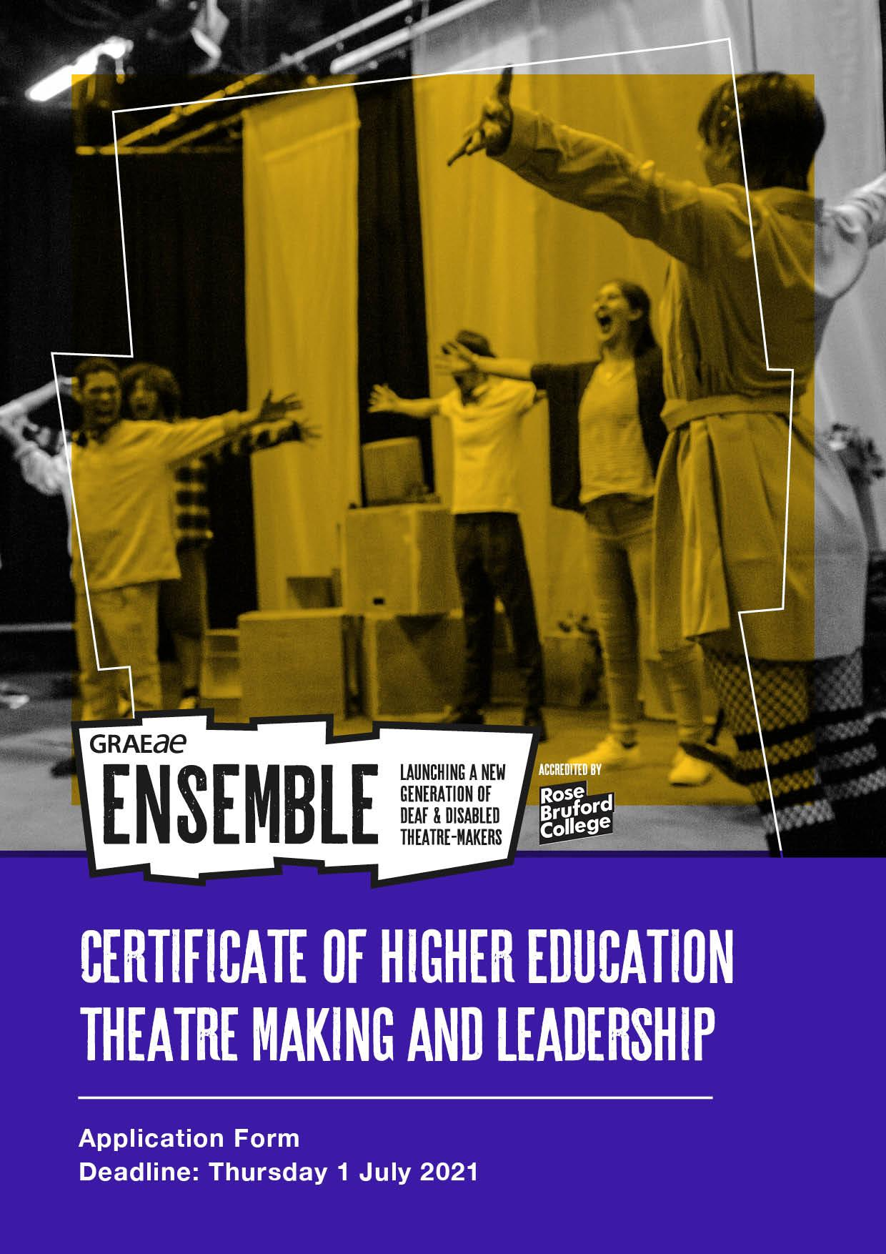

This is the application form to join Graeae Ensemble for the Certificate of HE (Level 4) Theatre Making and Leadership course.
Ensemble brings world class training directly to Deaf and disabled young people (aged 17 – 30) who are passionate about theatre, driven towards a career in the arts and eager to challenge themselves professionally. It provides young artists a well-rounded knowledge and experience of performing and theatre making, both on and off stage.
The Ensemble course includes units on Improvisation, Acting Techniques, Approaches to Text, Theatre for Social Change, and introduces the Aesthetics of Access, Graeae’s unique approach to performance making.

IMPORTANT

Please read the course content and programme specifications carefully before submitting your application

Please answer all questions on this form clearly. We welcome applications in whichever format is accessible for you - written English, an audio recording, video (BSL/SSE/spoken)
- In each of your answers please give us as much detail as possible about your passion, ambition and why you want to be on this course.

If you need any assistance filling in the application or have questions, please contact:
Graeae’s Training & Learning team:

Mette Tofte Philipsen, Training & Learning Coordinator

Jodi-Alissa Bickerton, Creative Learning Director

Email: training@graeae.org

Please assure us of your availability by ticking the boxes:
Discover week
This is the short course you must attend to be considered for the full-time Ensemble course. It includes taster workshops and an audition.
Monday 6 September – Friday 10 September 2021
11am – 4pm

Ensemble: Cert HE in Theatre Making and Leadership

This course is a full time Level 4 course accredited by Rose Bruford College. The course fee is £9,250 and you can apply to Student Finance for a student loan.
22 November 2021 – 22 December
Wednesdays and Thursdays only
Induction with practical and online delivery
10 January – 29 July 2022
3 days a week: practical sessions, up to 4 days during rehearsal periods
2 days a week: non-contact course work

1. Personal Information
First Name:
Surname:
Date of Birth:
Full Address:
Mobile number:
Home number:
Email:
Please specify your preferred means of communication e.g. Telephone, Email, Skype, SMS/Text or other (please include which)

Emergency contact
Full Name:
Phone:
Email:
Relationship to you:

2. Personal Statement, why you would like to join Ensemble and take part in the Cert HE Theatre Making
and Leadership course?
You may like tell us about your ambitions, what excites you about theatre, how you would like to develop as an artist and be challenged.

3. Experience (participatory, voluntary or paid)
a) List any previous experience you have had in theatre (e.g. performances, production roles, workshops, or other opportunities etc)

b) What have you learned from these experiences?

4. Education
Please list your secondary, further or higher education history.

5. What would you like to bring to the course and why would we enjoy working with you?

6. Creative Challenge
If money was no object, what theatre production or participatory arts project would you like to create and why?
Include:
- The title
- What is it about? A plot summary or description of the production or project.
- Why is it important? Why now?
- Where would it be performed/delivered? Why?
- What would you hope to achieve by producing this?
- Who is the audience?
- What role/s would you love to have in this production or project?

7. Personal Response
Graeae’s mission has always been to train, develop and provide a platform for Deaf and disabled artists across the industry. By joining Ensemble, you would become part of this vital mission.
“There are still not enough Deaf and disabled actors employed in stage, and screen roles today.” Please discuss and give your opinion.

8. References
Please provide one professional reference who may be familiar with your performance experience and interest (e.g. a teacher, tutor, workshop facilitator, mentor, youth worker)
Name:
Role and organisation (if relevant):
Telephone/mobile:
Email:
Relationship to you:

9. Access
We will always be delivering training from fully accessible spaces and venues. We provide BSL interpreters and Access Support Workers across all stages of the course.
If you are offered a place on Discover, you will need to fill in an access audit and return to us by Friday 23 July 2021.

10. How did you find out about this course?
E.g. social media, a friend, Graeae’s website, Rose Bruford’s website? Please indicate below.

11. Declaration
I confirm that all the information I have provided on this form is correct.
Signed:
Date:
Please return your application on Thursday 1 July 2021 to:

Mette Tofte Philipsen, Training & Learning Coordinator
training@graeae.org

