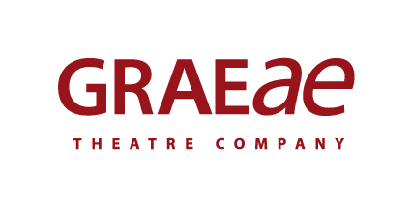
Recruitment Monitoring Form – Artist Development Administrator

Graeae is an Equal Opportunities employer. This means that everyone who works for us is treated equally, whatever their race, colour, ethnic or national region, sex, marital status, responsibility for children or dependents, disability, sexual orientation, religion or political beliefs.

To ensure this policy is effective we request you complete this form and return it with your application. This monitoring form is for statistical purposes only and will be kept separate from the information used in the selection process.

1. Gender Identity

Do you identify as:
Male
Female
Non-binary
Prefer not to say

If the gender you have now is different to what you were assumed to be at birth, please tick this box.

2. Age

0-19 20-34 Prefer not to say
35-49 50-64
Over 65

3. Cultural Diversity

Ethnic origin is not about nationality, place of birth or citizenship. It is about the group to which you perceive you belong. Please tick the appropriate box

White
British Irish Gypsy or Irish Traveller Prefer not to say
Any other white background, please write in:

Mixed/multiple ethnic groups
White and Black Caribbean White and Black African White and Asian Prefer not to say Any other mixed background, please write in:

Asian/Asian British
Indian Pakistani Bangladeshi Chinese Prefer not to say
Any other Asian background, please write in:

Black/ African/ Caribbean/ Black British
African Caribbean Prefer not to say
Any other Black/African/Caribbean background, please write in:

Other ethnic group
Arab Prefer not to say Any other ethnic group, please write in:

4. Disability

Do you consider yourself to be:
Deaf, disabled or have a long-term health condition
Non-disabled
Prefer not to say

The information in this form is for monitoring purposes only. If you have any access requests there will be opportunities to request this through the Access Audit issued by our Access Manager.

5. Sexual Orientation

What is your sexual orientation?
Heterosexual Gay woman/lesbian Gay man Bisexual/Pansexual
Queer Prefer not to say If other, please write in:

6. Recruitment

How did you learn about this vacancy?

Graeae Newsletter Disability press ____________
Graeae Website Arts Jobs UK
Twitter Facebook
Other (please state):___________________________________

7. Declaration of Consent

Graeae uses this information to review compliance with its policies on equal opportunity in relation to recruitment. We will use this data to inform our statistics on the representation of the categories of individual as shown above. We will treat all personal information in line with current data protection legislation and our data protection policy. For more information on how we use the information you have provided, please see our job applicant privacy notice which is available on our website.

In order for us to process this information and to comply with data protection legislation, we require your consent. You are not required to give your consent; you acknowledge that any consent given is freely given. Your job application is not dependent on your giving consent to our processing of this data.

Including your signature below will signify your consent to our processing of this information. Once you have given consent, you may withdraw it at any time by contacting Kevin Walsh, Operations Director on kevin@graeae.org.

Signature:

Date:

