Graeae, Cast, Hull Truck Theatre Nottingham Playhouse, Octagon, Shakespeare North, Liverpool Everyman, Derby Theatre
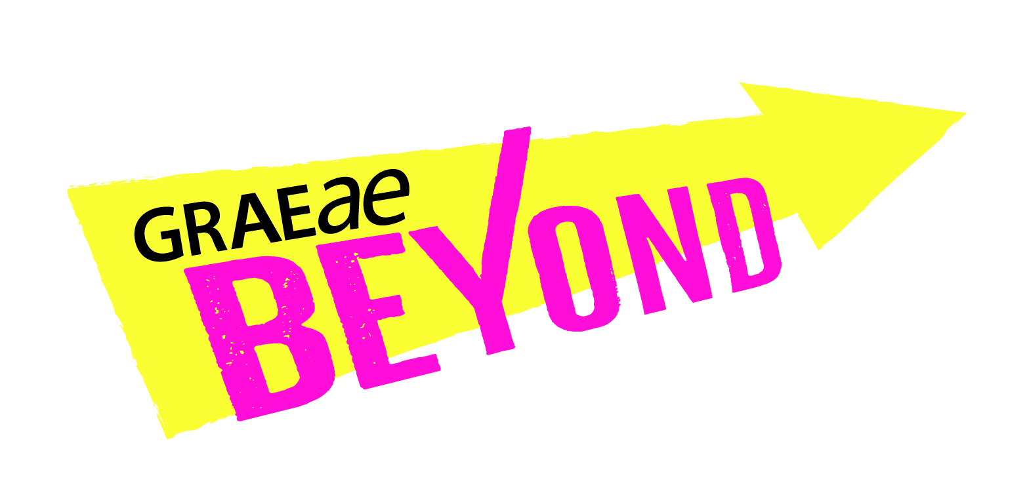

Expression of Interest form (EOI form)

General Information
Please ensure you have accessed our Information for Artists.

We welcome Expressions of Interest in any format accessible to you including written English, an audio recording, video (BSL/SSE/spoken) or via a meeting. If you require access support in completing your Expression of Interest please let us know.

If you would like to contact us for more information before submitting your Expression of Interest, please contact Laura Guthrie, Artist Development Manager, laura@graeae.org

Criteria
By submitting your Expression of Interest (EOI), you confirm that you:
- Identify as Deaf or Disabled, neurodivergent or have experienced access barriers to working in theatre
- Have been involved in creating live performance professionally (can be hybrid or digital versions) with or without formal training
- Have an idea for a live performance project you are passionate about taking further (can be hybrid or digital ideas)
- Aged 18 years or over
- You are based in England
- Would benefit from support by an English regional theatre in the North, North East, North West, or East Midlands

Guidelines
- Complete responses to all questions outlined below in this form. Incomplete responses to Expressions of Interest (EOI) could delay our response, due to the high volume of applications we receive.

- Send both your Expression of Interest (EOI) and confidential Equal Opportunity & Monitoring information to manishta@graeae.org

- We will send you a confirmation email within 1 week of receiving your Expression of Interest (EOI).

- Here is a timeline to the application process:

- Submit your EOI form by 5pm 26th June 2023. We will confirm that your application has been received.
- We will inform all shortlisted artists by 3rd July
- We will arrange informal interviews with shortlisted artists during July & August. More details will be sent at a later stage
- The programme will formally start in September

Your Expression of Interest (EOI)

- About you
First Name/s: Surname:

Pronouns:

Full Address:

Landline:

Mobile:

Email:

Please select your preferred means of communication(s):
Telephone:
SMS:
Email:
Skype (include your username):
Zoom:
WhatsApp:
Other (specify):

Please indicate which partner theatre/s is or are located nearest to you? Tick as many as are appropriate.
North: Cast in Doncaster
North: Hull Truck Theatre in Hull
North West: Shakespeare North Playhouse in Prescot
North West: Everyman Theatre in Liverpool
North West: Octagon Theatre, in Bolton
East Midlands: Derby Theatre in Derby
East Midlands: Nottingham Playhouse in Nottingham
Please tell us if you have had a previous relationship with any of these theatres?

- Your Statement of Interest
- In 250- 300 words, please tell us about yourself and how you would like to benefit from BEYOND. Please include a summary of your artistic practice to date and your specific interests or areas of work.

- In 200 - 250 words share an idea you would like BEYOND to support you in taking further. You can include photos/images also.

- OPTIONAL: Feel free to describe any access-related or other barriers you have faced which may have prevented you previously from fully exploring your artistic practice.

- Your career
- In approximately 250 words please tell us where you would like BEYOND to take you in your career.

- Are there any areas that you feel you need particular support in such as producing, marketing, financial management, networking, showcasing opportunities etc.?

- Declarations
- I confirm that all the information I have supplied on this form is correct and meets the criteria for eligibility.
- We will be sharing your EOI form with the Beyond partner venues. However, your contact details will not be shared until you are on the programme and have a connection with a Beyond partner venue.
- To find out more, please see Graeae’s complete Privacy Policy here: https://graeae.org/privacy-policy/. I confirm to Graeae storing my information in line with data protection legislation and privacy policy:

Signed / Your Name:

Thank you!

Please send your Expression of Interest and Equal Opportunities & Monitoring information to:
Manishta Sunnia, Artist Development Coordinator

manishta@graeae.org

www.graeae.org/beyond

