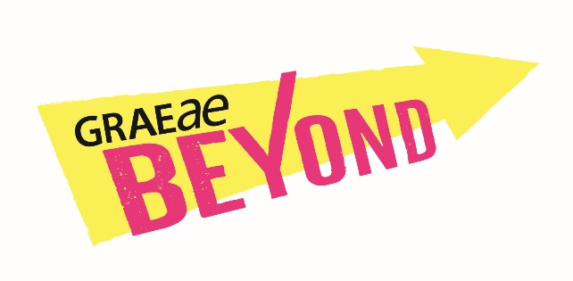
Image?

Beyond is Graeae’s bespoke Artist Development programme, started in 2020 it has supported 48 Deaf, disabled and neurodivergent artists in developing their careers, taking
on new challenges & building successful connections.

“I entered the programme an emerging artist and
I am leaving a mid-career artist with a plethora
of experience, connections and opportunities all
stemming from this programme.”
(Beyond Artist)

Beyond is helping to develop greater access to regional
opportunities across England ensuring Deaf, disabled and
neurodivergent artists are at the forefront of new and emerging work. We recognise the immense value of our intersectionality across our communities, which includes Black, Asian, Global Majority, migrant, and LGBTQIA+ artists, which is why our
approach is to be as bespoke as possible for each individual artist on the programme.

“The industry is saturated with full-on training
opportunities and I find that quite exhausting.
What sets Beyond apart, and what makes a difference is it is bespoke… designed for you.”
(Beyond Artist)

Graeae have teamed up with seven leading venues across
England:
- Octagon Theatre, Bolton
- Nottingham Playhouse
- Cast in Doncaster
- Hull Truck Theatre
- Shakespeare North in Prescot
- Everyman in Liverpool
- Derby Theatre.

Together we are creating a national network of artistic support and development for Deaf, disabled and neurodivergent artists.

“The support [ from venues ] has been immense. Knowing that there is an interest for disability art in the mainstream and that there are theatres who want to make contact is incredibly powerful.”
(Beyond Artist)

“The artists are all really confident and know how to ask for support and feel empowered to talk about their work. They have a plan for their careers.
That’s come from the Beyond programme.”
(Beyond Venue)

Beyond gives breathing space for artistic ambition and for
discovery of creative potential.

“I am so confident now when entering a room, working on a project, going to an audition. Because of this project
I understand how to hold myself as a professional in the
industry.”
(Beyond Artist)

When?
- The programme runs from September 2023 until March 2025
- The amount of time spent on the programme is set by each individual artist according to their availability.

What?
The programme offers 18 months of bespoke support,
including:
- mentoring
- practical resources, such as industry specific workshops
- creative spaces
- micro-bursaries
- networking opportunities
- support with funding applications

Where?
- This programme is designed to support artists who could most benefit from alliances with regional theatres in the North, North East, North West and East Midlands.
- You might live, work or have a deep connection with any of the areas where partner theatres are based:
Bolton, Prescott, Nottingham, Derby, Hull, Liverpool or
Doncaster.

Access
- Graeae has a designated Access Manager who will
oversee provision of access for all the artists, both in the application process and once artists are on the
programme itself.
- Artists’ access requirements will be met by Graeae or by your connected regional theatre.
- If you choose and if appropriate, you can also be
supported in applying for Access to Work.

Who can apply?
- You can apply if you are over 18 years old
- You can be at the start, middle or be many years into your career.
- You just need to have a record of commitment to creating live performance (online or in person) as a performer, writer, director, producer, designer or technician.
- There are twenty places available to Deaf, disabled or
neurodivergent artists who want to create live
performance, develop an idea, find new collaborations,
be seen and heard, but cannot get beyond barriers
to developing or continuing their practice.

How to apply:
Stage 1
Complete an Expression of Interest Form.
You can download the form here: link…
The form can be completed in any format accessible to you:
- audio recording
- BSL video
- word doc
- via a supported online conversation with Laura Guthrie, Artist Development Manager.

The final date for submitting Expression of Interest form is Monday 26 June 2023.

Stage 2
Meeting Invitation:
Your Expression of Interest form will be read by Graeae and a partner venue. If it is clear Beyond could be a useful
programme for you, a meeting in July or August will be set up for us to talk with you about your work.

Stage 3
Programme invitation:
Following the meeting, if we are all sure Beyond is right for you, we will send you confirmation of your place on the programme by September 2023.

For more information contact:
Manishta Sunnia
Artist Development Coordinator
manishta@graeae.org
With thanks to our funders:
Arts Council…

To Apply:
All forms, in a variety of accessible formats can be downloaded from the bottom of the webpage www.graeae.org/beyond

We welcome applications in any format accessible to the artist.

