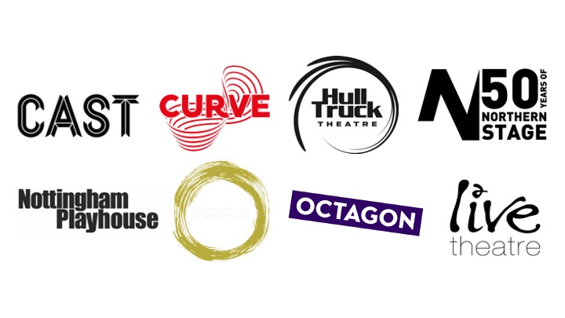
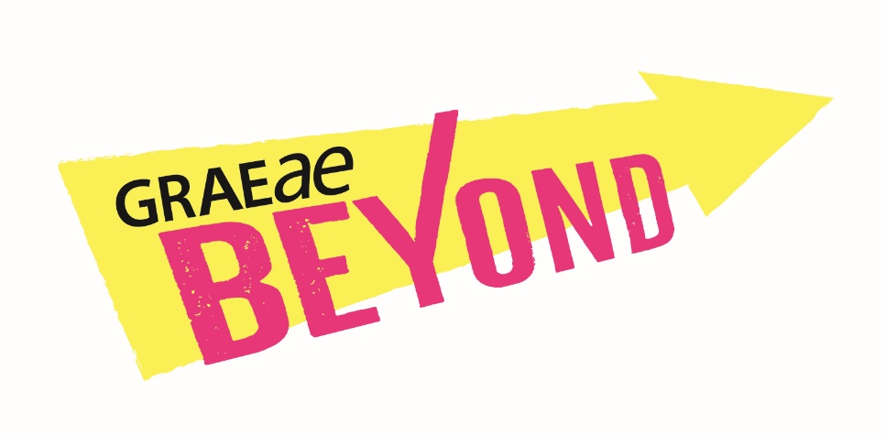

Information for Artists

- Are you a Deaf or Disabled artist that wants to be part of the changing landscape of theatre in England?
- Are you a passionate artist who wants to create live performance, develop an idea, find new collaborations, be seen & heard, but cannot get beyond barriers to developing or continuing your practice?

BEYOND is designed to transform the careers of Deaf and Disabled artists, supporting new connections to artistic development opportunities, advice, training, mentoring and creative spaces within a national network of theatres.
These are testing times for creatives everywhere, but in this changed cultural landscape we are looking to the future.

We are developing greater access to regional opportunities across England ensuring Deaf and Disabled artists are at the forefront of new and emerging work. We recognise the immense value of our intersectionality across our communities which includes Black, Asian, ethnic minority and LGBTQIA+ artists.
BEYOND is a new venture in artist development, opening up access to untapped resources in major regional theatres and offering you much needed creative ‘breathing space’.
Graeae is looking to connect with Deaf & Disabled artists who are passionate creatives in any aspect of theatre.
BEYOND is delivered in collaboration with a thriving network of partner theatres including:
- Cast, Doncaster
- Curve, Leicester
- Hull Truck Theatre, Hull
- Live Theatre, Newcastle
- Northern Stage, Newcastle
- Nottingham Playhouse, Nottingham
- Octagon Theatre, Bolton
- Shakespeare North, Prescot

Artists can benefit from BEYOND in one or more of the following ways. All access requirements will be met.
- Creative space and support to explore theatrical ideas
- Shadowing opportunities within R&D and rehearsal processes
- A share in 600 hours of rehearsal space
- A share in 100 hours of mentoring support
- Support in sourcing funding and bursaries
- Bespoke introductions to accessible opportunities near you
In addition to space, time and people, we will be offering a number of Micro Grants to unlock additional resources and help projects achieve their full potential.

BEYOND will connect you to this network of venues offering access to bespoke support and enabling you to elevate your careers by realising an idea or developing specific skills that lead to further work within the industry. Artists will be building lasting relationships with one or more theatres based on a shared learning process as both navigate through the changing cultural landscape. These relationships will provide further career development possibilities beyond the programme, supporting you to create work that is sustainable and responsive to the current climate and beyond.

If you are already an established artist but find barriers are preventing you from taking yourself or your work to the next level, you might be an early stage artist or are returning to theatre after a break.

Getting Involved:
Complete an Expression of Interest (click here)

Criteria:
- Identify as Deaf or Disabled or have experienced access barriers to working in theatre
- Have been involved in creating live performance professionally, with or without formal training
- Have an idea for a live performance project you are passionate about taking further
- Aged 18 years or over
- Would benefit from support by a regional theatre in the North, North East, North West of England or East Midlands.

You can contact us to discuss your desire to be part of BEYOND at any time.

What Happens After I Submit My Expression of Interest?
Once we receive your Expression of Interest, we will confirm receipt within 1 week. We will then contact you within 4 weeks, via your preferred method of communication, to discuss your project and/or ambitions and how we could support you. Incomplete responses to Expressions of Interest could delay our response, due to the high volume of application we receive.
CONTACT:
Laura Guthrie, Artist Development Manager, laura@graeae.org

