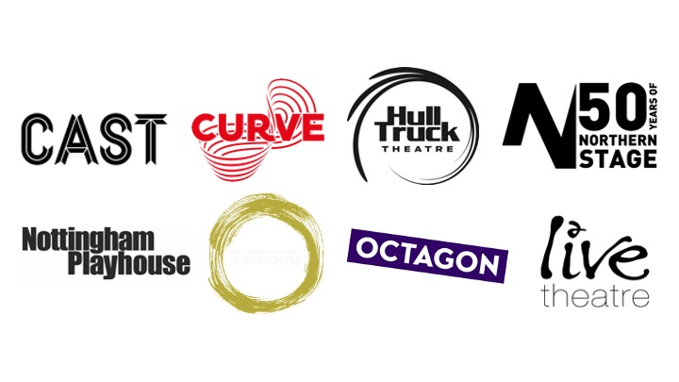
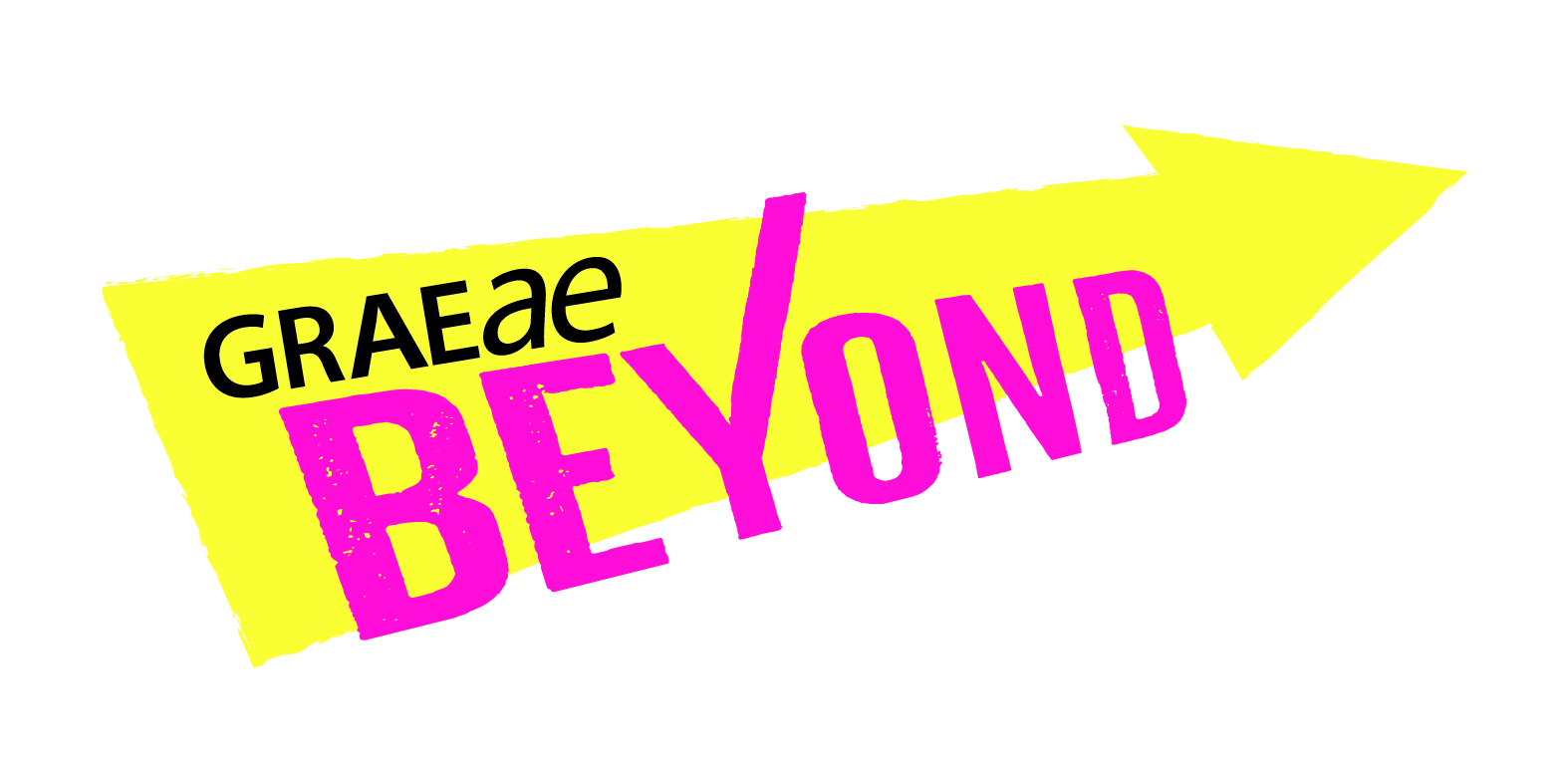

Expression of Interest

General Information
Please ensure you have had accessed our Information for Artists.

We welcome Expressions of Interest in any format accessible to you including written English, an audio recording, video (BSL/SSE/spoken). If you require access support in completing your Expression of Interest please let us know.

If you would like to contact us for more information before submitting your Expression of Interest, please contact Laura Guthrie, Artist Development Manager, laura@graeae.org

Criteria
By submitting your Expression of Interest, you confirm that you:
- Identify as Deaf or Disabled or have experienced access barriers to working in theatre
- Have been involved in creating live performance professionally, with or without formal training
- Have an idea for a live performance project you are passionate about taking further
- Aged 18 years or over
- Would benefit from support by a regional theatre in the North, North East, North West of England or East Midlands.

Guidelines
- Complete responses to all questions outlined below in the Expression of Interest form. Incomplete responses to Expressions of Interest could delay our response, due to the high volume of application we receive.

- Send both your Expression of Interest and confidential Equal Opportunity & Monitoring information to laura@graeae.org

- We will send you a short confirmation email within 1 week of receiving your Expression of Interest. We will then be in touch within 4 weeks to follow up with you further, in detail.
Your Expression of Interest

- About you
First Name/s: Surname:

Full Address:

Landline:

Mobile:

Email:

Please select your preferred means of communication(s):
Telephone:
SMS:
Email:
Skype (include your username):
Zoom:
WhatsApp:
Other (specify):

Please indicate which partner theatre/s is located nearest to you? (Delete from the below list as necessary)
Octagon Theatre, Bolton
Curve, Leicester
Nottingham Playhouse, Nottingham
Cast, Doncaster
Hull Truck Theatre, Hull
Shakespeare North, Prescot
Live Theatre, Newcastle
Northern Stage, Newcastle
Please share with us if you have had a previous relationship with any of these theatres?

- Your Statement of Interest
- In 250- 300 words, please tell us about yourself and how you would like to benefit from BEYOND. Please include a summary of your artistic practice to date and your specific interests or areas of work.

- In 200 - 250 words share an idea you would like BEYOND to support you in taking further. You can include photos/images also.

- OPTIONAL: Feel free to describe any access-related barriers you have faced which may have prevented you previously from fully exploring your artistic practice.

- Your career
- In approximately 250 words please tell us where you would like BEYOND to take you in your career.

- Are there any areas that you feel you need particular support in such as producing, marketing, financial management, networking, showcasing opportunities etc.?

- Declarations
- I confirm that all the information I have supplied on this form is correct and meets the criteria for eligibility.

Yes / No?

Signed / Your Name:

- Please indicate the communication methods (if any) that you’d be happy to pass onto the BEYOND partner venues:

Full address: Yes / No?
Email: Yes / No?
Phone: Yes / No?
This will be to help ensure that you are kept up to date with opportunities that may be of interest and are relevant to you. No other personal information apart from your name and the contact information you agree to will be shared.

OR

I don’t want any of my information shared beyond Graeae: Yes/No?

Graeae’s complete Privacy Policy is here: https://graeae.org/privacy-policy/

Thank you!

Please send your Expression of Interest and Equal Opportunities & Monitoring information to:
Laura Guthrie, Artist Development Manager
laura@graeae.org

www.graeae.org/beyond

