Discover: a short course in theatre-making

Application Form
Apply before Tuesday 24th of September 2019

This is the application form for Discover, a free one-week short course in theatre-making and technical production roles.
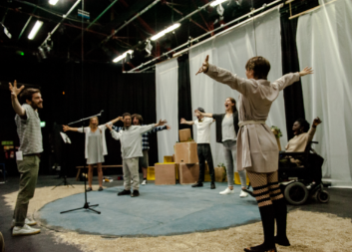
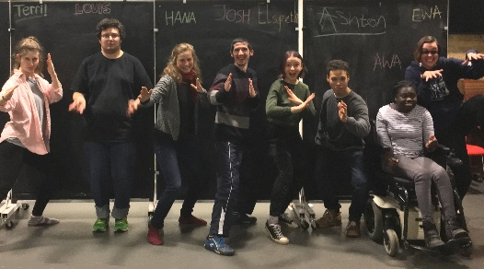
It is designed for Deaf and disabled people aged 17 - 30 who are passionate about theatre, would like a career in the arts and are ready to challenge themselves professionally.

The course will explore theatre-making, both on and off stage, and is also the chance to be considered for more of Graeae’s training opportunities in 2020.

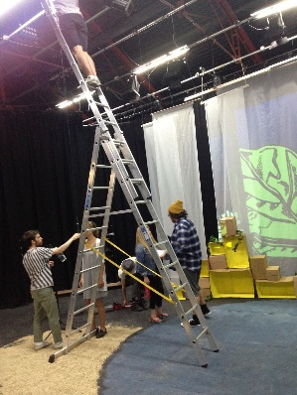
The programme includes workshops in Technical Theatre,

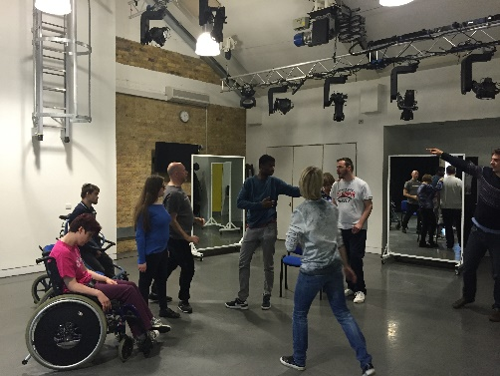
Devising Performances

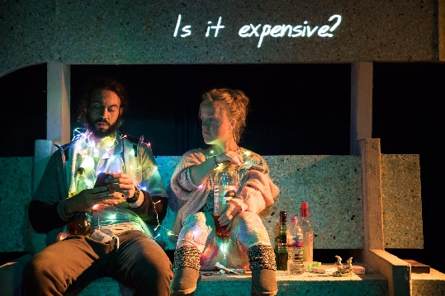
and Creative Access in Theatre-Making.

IMPORTANT

Please read the Discover: short course brief carefully before submitting your application. An Easy Read version is available.
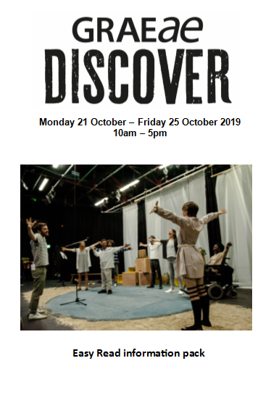

Please answer all questions on this form clearly in type or in black or blue ink. You can send us your answers in a video or sound recording instead, if this is easier for you.

- In each of your answers please give us as much detail as possible about your passion, ambition and why you want to be on this course.

If you need any help filling in the application or have questions, please contact:
Graeae’s Training & Learning team:
Jodi-Alissa Bickerton, Creative Learning Director
jodi@graeae.org / 020 7613 6900

Mette Tofte Philipsen, Training & Learning Coordinator mette@graeae.org / 020 7613 6900

Are you free to take part in:
Discover: short course in theatre-making
Monday 21 October – Friday 25 October 2019
10am – 5pm (plus up to 2 evening shows)
YES or NO

Further training programmes in 2020
If you wish to be considered for more Graeae training in 2020 and you are available to train up to 3 days a week from January – July 2020 please tick
YES or NO

- Personal Information – all about you.
First Name:
Surname:
Date of Birth:
Full Address:
Mobile number:
Home number:
Email address:
How would you like us to contact you?
Phone
Email
Text Message
Skype / Video Call
Other

Emergency contact (who would you like us to call if something is wrong)
Full Name:
Phone:
Email:
Relationship to you:

2. Personal Statement. Why you would like to take part in this course?
Tell us about your interests,
why you want to take part,
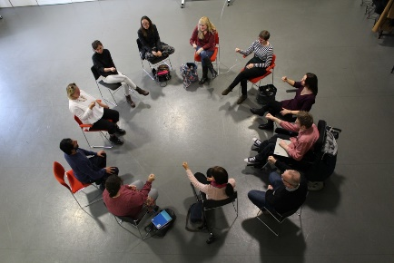

what you love about theatre,
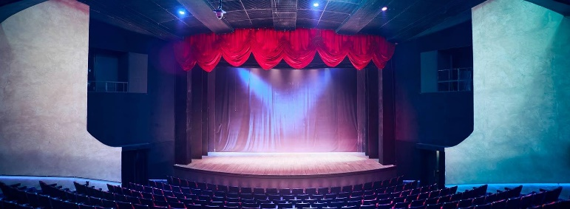
and your targets.

3. Experience (participatory, voluntary or paid)
a) List any previous experience you have had in theatre (e.g. performances, production roles, workshops, or other opportunities etc)

b) What have you learned from these experiences?

4. Education
Please list your education history if you think it is important.

5. What would you like to bring to the course and why would we enjoy working with you?

6. Creative Challenge – your ideas
If you had all the money that you need, what theatre or arts project would you like to create? Why? Describe your vision (what would it look like, who would be involved, what would you hope to achieve). What would you do in this project?

7. Personal Mission
Graeae’s mission has always been to train, develop and provide a platform for Deaf and disabled artists across the industry. By joining this course, you would become part of this vital mission.
“There are still not enough Deaf and disabled artists employed in theatre roles today.” Please discuss and tell us what you think.

8. References
Please provide one professional reference who can tell us about your performance experience and interest (e.g. a teacher, tutor, workshop facilitator, mentor, youth worker)
Name:
Role and organisation (if relevant):
Telephone/mobile:
Email:
Relationship to you:

9. Access
Graeae’s building is fully accessible and we provide BSL interpreters and access support workers across all stages of the programme. If you are offered a place on Discover, we will write to you and ask you what you need.

10. Declaration
I confirm that all the information I have provided on this form is correct.
Signed:
Date:

Please return your application by Tuesday 24 September 2019 to:
Mette Tofte Philipsen
Training & Learning Coordinator
Graeae Theatre Company,
Bradbury Studios, 138 Kingsland Road,
London E2 8DY

OR
send via email to mette@graeae.org

