Ensemble: Discover (Short Course)
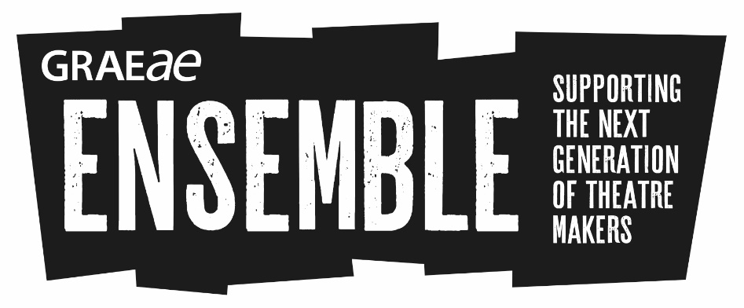 | This information is about Ensemble: Discover.
 | Ensemble is led by Graeae Theatre.

What is it?
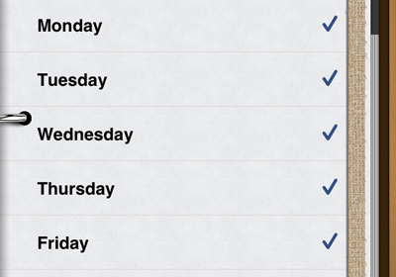 | Ensemble: Discover is a 5 day course in theatre making.
 | Ensemble: Discover is for young Deaf and disabled people aged 17-30 who want to work in theatre.
 | Drama schools will be involved in the course. These are LAMDA, Rose Bruford College, Royal Central School of Speech and Drama and RADA.
 | There are 20 places on the course.
 | If you do this course you might be chosen to do another longer course in January to March 2018. There will be 10 places on this course.

What happens on the course?
You will do workshops and masterclasses in different theatre skills.

A masterclass is when you work with an expert to find out about a subject.

 | You will see 2 shows.
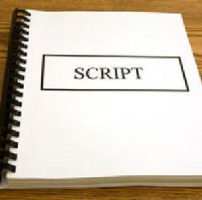 | You will do workshops and masterclasses in different subjects including acting, text and technical theatre.
 | We will make sure we meet everybody’s access needs.

When and where
 | Ensemble: Discover is a course which will run from Monday 23 October to Friday 27 October 2017.
 | The sessions will run from 10am to 5pm.
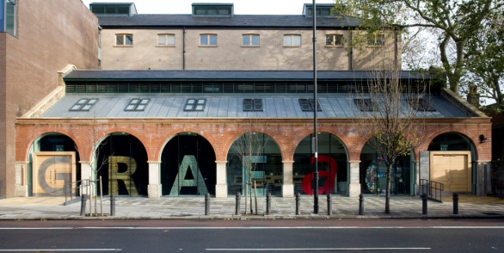 | It will happen at Graeae in Hackney. There will be some sessions in other places across London. All the places will be accessible.

How to apply
You should fill out the application form on the Graeae website.

You can send us a BSL video if you are a BSL user.

How to contact us
If you want to find out more, you can contact Jodi.

Email jodi@graeae.org or call 020 7613 6900.

