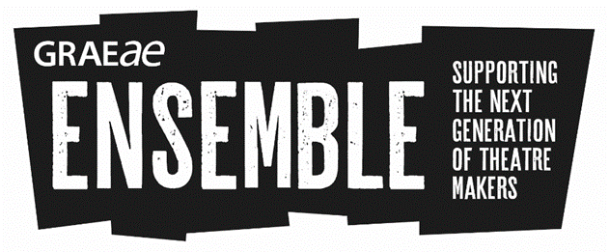
Application Form
Deadline: Monday 2 October 2017

This is the application form for Ensemble Discover and Train. It is designed for young D/deaf and disabled people aged 17-30 who are passionate about a career in the theatre industry. The programme includes processes in Technical Theatre, Directing, Performance and Devising and will give the trainees a well-rounded knowledge and experience of theatre making, both on and off stage.
IMPORTANT

Please read the Ensemble Discover and Train brief carefully before submitting your application

Please answer all questions on this form clearly in type or black/blue ink. We also welcome applications in other formats, e.g. BSL video or Braille
- In each of your answers please give us as much detail as possible about your passion, ambition and any experience

If need any assistance filling in the application or have questions, please contact: Jodi-Alissa Bickerton, Creative Learning Director jodi@graeae.org / 020 7613 6900

Please assure us of your availability by ticking the boxes:
Stage 1: Short Course (Ensemble Discover)
Monday 23 October – Friday 27 October 2017
10am – 5.30pm (plus attendance at up to 2 evening performances)

Stage 2: Ensemble 2018 (Ensemble Train)
Thursday 11 January – 27 April 2018 (Thursdays Fridays)
10am – 6pm

- Personal Information
First Name:
Surname:
Date of Birth:
Full Address:
Mobile number:
Home number:
Email:
Please specify your preferred means of communication e.g. Telephone, Email, Skype, SMS/Text or other (please include which)

2. Personal Statement, why you would like to join the Ensemble.
You may like tell us about your ambitions, what excites you about theatre, how you would like to develop as an artist and be challenged.

3. Experience (participatory, voluntary or paid)
a) List any previous experience you have had in theatre (e.g. performances, production roles, workshops, or other opportunities etc)

b) What have you learned from these experiences?

4. Education
Please list your education history

5. What would you bring to the Ensemble programme and why would we enjoy working with you?

6. Creative Challenge
If money was no object, what theatre or community arts project would you like to create and why? Describe your vision (what would it look like, who would be involved, what would you hope to achieve).
What role/s would you have in this project?

7. Personal Mission
For the past 37 years, Graeae’s mission has been to train, develop and provide a platform for D/deaf and disabled artists across the industry. By joining Ensemble, you would become part of this vital mission.
“There are still not enough D/deaf and disabled artists employed in theatre roles today.” Please discuss and give your opinion.

8. References
Please provide one professional reference who may be familiar with your performance experience and interest (e.g. a teacher, tutor, workshop facilitator, mentor, youth worker)
Name:
Role and organisation (if relevant):
Telephone/mobile:
Email:
Relationship to you:

9. Access
Graeae’s building is fully accessible and we provide BSL interpreters and access support workers across all stages of the programme. Access Audit Forms will be sent in advance to collect details of access requirements.

10. Declaration
I confirm that all the information I have provided on this form is correct.
Signed:
Date:

Please return your application by Monday 2 October to:
Jodi-Alissa Bickerton, Creative Learning Director
Graeae Theatre Company,
Bradbury Studios, 138 Kingsland Road,
London E2 8DY
or send via email to jodi@graeae.org

