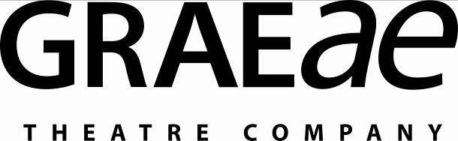

Recruitment Monitoring Form – Literary Assistant

Graeae is an Equal Opportunities employer. This means that everyone who works for us is treated equally, whatever their race, colour, ethnic or national region, sex, marital status, responsibility for children or dependents, disability, sexual orientation, religion or political beliefs.

To ensure this policy is effective we request you complete this form and return it with your application. This monitoring form is for statistical purposes only and will be kept separate from the information used in the selection process.

1. Gender

Male Female Other/Prefer not to say

2. Age

18 - 25 45 - 55
25 - 35 55 - 65
35 - 45 Over 65

3. Cultural Diversity

Please select the ethnic category that best represents you. As you make your decision, please think about what ethnic group means to you, that is, how you see yourself. Your ethnic category is a mixture of culture, religion, skin colour, language and the origins of yourself and your family. It is not the same as nationality.

White
British
Irish
Any other white background, please state__________________

Asian or Asian British
Asian Bangladeshi
Asian Indian
Asian Pakistani
Any other Asian background, please state__________________

Black or Black British
Black African
Black Caribbean
Any other Black background, please state _________________

Chinese or other ethnic group
Chinese
Any other, please state______________________

Dual Heritage
Dual Asian & White
Dual Black African & White
Dual Black Caribbean & White
Dual Chinese & White
Any other background, please state_____________

Any other background, please state_____________

4. Disability

Do you consider yourself to be:
Disabled Not disabled

5. Recruitment

How did you learn about this vacancy?

Graeae Newsletter Disability press ____________
Graeae Website Arts Jobs UK
Twitter Facebook

Other (please state):___________________________________

