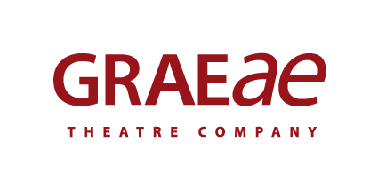
Recruitment Monitoring Form – Write to Play South West

Graeae is an Equal Opportunities employer. This means that everyone who works for us is treated equally, whatever their race, colour, ethnic or national region, sex, marital status, responsibility for children or dependents, disability, sexual orientation, religion or political beliefs.

To ensure this policy is effective we request you complete this form and return it with your application. This monitoring form is for statistical purposes only and will be kept separate from the information used in the selection process.

1. Gender Identity

Do you identify as:
Male
Female
Prefer not to say
Prefer to self-describe __________________________

Is your gender identity the same as the sex you were assigned at birth?
No
Yes
Prefer not to say

2. Age

0-19 20-34 Prefer not to say
35-49 50-64
Over 65

3. Cultural Diversity

Ethnic origin is not about nationality, place of birth or citizenship. It is about the group to which you perceive you belong. Please tick the appropriate box

White
English Welsh Scottish Northern Irish Irish
British Gypsy or Irish Traveller Prefer not to say
Any other white background, please write in:

Mixed/multiple ethnic groups
White and Black Caribbean White and Black African White and Asian Prefer not to say Any other mixed background, please write in:

Asian/Asian British
Indian Pakistani Bangladeshi Chinese Prefer not to say
Any other Asian background, please write in:

Black/ African/ Caribbean/ Black British
African Caribbean Prefer not to say
Any other Black/African/Caribbean background, please write in:

Other ethnic group
Arab Prefer not to say Any other ethnic group, please write in:

4. Disability

Do you consider yourself to be:
d/Deaf or Disabled Non-disabled Prefer not to say

The information in this form is for monitoring purposes only. If you have any access requests there will be opportunities to request this through the Access Audit issued by our Access Manager.

4. Sexual Orientation

What is your sexual orientation?
Heterosexual Gay woman/lesbian Gay man Bisexual/Pansexual

Prefer not to say Prefer to self-describe __________________________

5. Recruitment

How did you learn about this vacancy?

Graeae Newsletter Disability press ____________
Graeae Website Arts Jobs UK
Twitter Facebook
Other (please state):___________________________________

