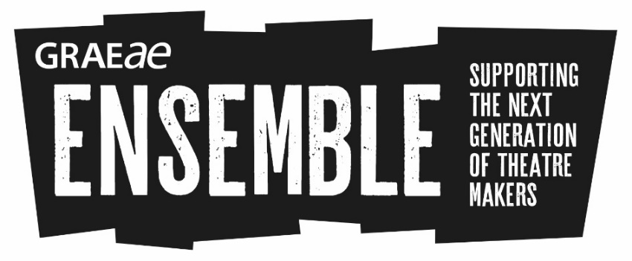

Ensemble: Discover (Short Course)

Monday 23 October – Friday 27 October 2017
10am – 5.30pm
Graeae Theatre Company, London

Apply for this course to be considered for Ensemble 2018.

This is a one-week short course in theatre making and technical production roles. It is open to young D/deaf and disabled people (aged 17-30) who are passionate about theatre and driven towards a career in the arts.
To help us deliver this course, we are working with London’s leading drama schools including LAMDA, Rose Bruford College, Royal Central School of Speech and Drama and RADA, alongside some of the industry’s best and most inclusive practitioners.
We have 20 places available on this short course. We will then select 10 to progress onto the Ensemble 2018 programme in January – April 2018.
The short course is delivered in three parts: 2 practical workshops and a masterclass at the end of the day.
You will also be required to attend at least 2 evening performances as part of this course (tickets provided by Graeae).

Workshops and Masterclasses include:
- Acting technique
- Approaches to text
- Improvisation
- Theatre for Social Change
- Technical Theatre

All access support will be provided e.g. access worker, sign language interpreters. Travel costs will be covered inside of London where public transport is not possible due to access barriers.
This short course is based at Graeae in Hackney, London and at various accessible venues, campuses, and locations across London.
This course is free of charge.
To apply to Ensemble download the Application Form. Send us your completed form or a BSL video.
How do I apply?

To be eligible to apply, you:
- Will have a passion for developing a career in the arts and be excited by theatre
- Are between 17 and 30 years of age
- Are D/deaf or disabled, or have faced barriers to formal training, further education and/or employment due to your access needs not being met
To find out more, contact:
Jodi-Alissa Bickerton, Creative Learning Director
jodi@graeae.org
Tel: 0207 613 6900

