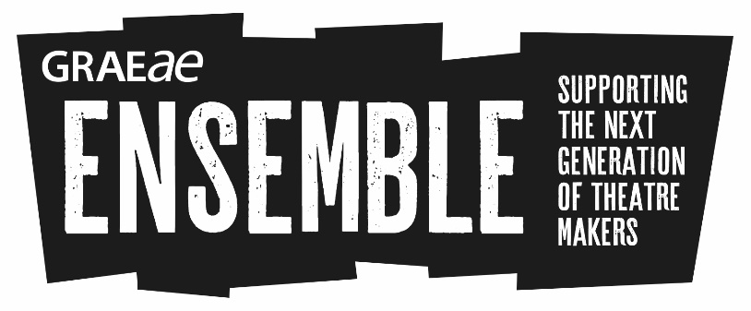
What is Ensemble?

Graeae’s Ensemble is a pioneering artist development programme for young D/deaf and disabled people passionate about theatre. If you do not identify as D/deaf or disabled, but have found it difficult to train or work in theatre due to a lack of access support, this is still for you.
The programme is delivered by Graeae alongside London’s leading drama schools, arts organisations and freelance theatre artists.
Our recent intake of Ensemble artists (2015-16) have gone on to work in the industry as award nominated performers, theatre makers, assistant directors and securing a place in higher education drama courses.
In 2018, Ensemble artists will receive training in:
- Performance techniques
- Creating theatre for social change
- Technical theatre skills
- Approaches to Classic and Contemporary Texts
- Actor preparation (breathing, movement, characterisation)
- Workshop facilitation

Artists will also receive:
- Theatre trips
- Networking opportunities
- A creative mentor
- Ongoing support from Graeae beyond the programme

Access support is provided across programme, for e.g. access worker, sign language interpreters. Travel bursaries are also available for artists facing barriers to accessible transport within London.
Ensemble training will be delivered across two stages:
How is Ensemble delivered?

Stage 1: Ensemble: Discover (1 week)
October 2017
Short Course in theatre making and technical theatre roles
20 places available
Stage 2: Ensemble: Train (Thursdays and Fridays)
11 January to 27 April 2018
Extended training course in theatre making, exploring on and off stage technique The course culminates in a sharing of performances and skills through workshops/presentations.
10 places available
Ongoing work-based learning opportunities can include:
- Devising new work culminating in an industry showcase
- Rehearsing and touring a Graeae Ensemble production
- Leading community engagement sessions
- Undertaking Arts Award Gold
Our creative partners include artists and performance companies from across the arts and theatre industry plus:
- LAMDA
- Rose Bruford College
- Royal Central School of Speech and Drama
- RADA

Ensemble is based at Graeae in Hackney, London and at various accessible venues, campuses, and locations across London.
This training programme is free of charge.

Who is eligible and how to apply?

To apply to Ensemble you:
- Will have a passion for developing a career in the arts and be excited by theatre
- Be between 17 and 30 years of age
- Be D/deaf or disabled, or have faced barriers to formal training, further education and/or employment due to your access needs not being met
- Be based in London, or able to commute or relocate to fully participate in all aspects of the programme
- Can be available for the short course.
Apply for the Ensemble short course to be considered for Ensemble: Train 2018.
To find out more, contact:
Jodi-Alissa Bickerton, Creative Learning Director
jodi@graeae.org
Tel: 0207 613 6900

