PRESS KIT
Graeae Theatre Company, in association with Belgrade Theatre Coventry presents:

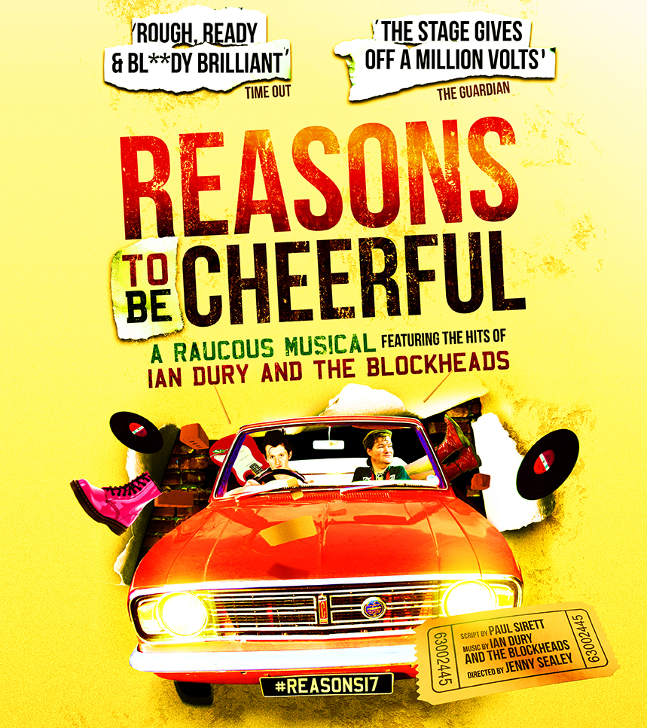
UK TOUR 2017
Supported by Arts Council England.

PRESS REPRESENTATIVES
The Corner Shop PR
36 Great Queen Street
London
WC2B 5AA
T: 020 7831 7657
Philippa Redfern
Abigail Jessup
philippa@thecornershoppr.com
abigail@thecornershoppr.com
PRESS KIT CONTENTS
INTRODUCTION....................................................................................................................................3
CAST BIOGRAPHIES 4
CREATIVE BIOGRAPHIES 7
SYNOPSIS 8
CHARACTERS 8
PROTEST SONG....................................................................................................................................9
CONTEXT AND HISTORY 10
PRESS ANGLES AND PHOTOCALL IDEAS 11
TOUR DATES AND VENUES 13
SOCIAL MEDIA 14
PRESS RESOURCES 14
AUDIO FLYER......................................................................................................................................14
ACCESS INFORMATION 15
BSL FLYER...........................................................................................................................................15
GRAEAE MEDIA LANGUAGE GUIDE 16
PRESS RELEASES 17
OTHER USEFUL CONTACTS 19

INTRODUCTION:
Reasons to be Cheerful, Graeae’s musical based on the music of Ian Dury and The Blockheads, has been seen in various guises since 2010, when it was first staged (and co-produced) with the New Wolsey Theatre, Ipswich and Theatre Royal Stratford East. It subsequently went on a national tour in 2012, visiting New Wolsey Ipswich (for a second time), Hall for Cornwall, Hull Truck, Watford Palace, Dundee Rep, Hackney Empire and Nottingham Playhouse. Also in 2012, the cast performed an excerpt (the song Spasticus Autisticus) at the London 2012 Paralympic Games Opening Ceremony, as well as a concert version of the show at the Queen Elizabeth Hall on London’s South Bank. Last year (2016), the concert version was revived for dates at Milton Keynes International Festival, Latitude Festival, and international gigs in Brazil and Mexico.

As is the Graeae way, the show has always been performed by an integrated cast, including Deaf and disabled artists, with creative integration of British Sign Language, audio description and captioning.
The 2017 tour will be a new production of the fully staged version, and it will be the last time that we take this show out (in that sense, it is a ‘farewell tour’). It will be going on a seven-venue tour from September 2017 (see tour venues on page 13) and has been funded by Arts Council England’s Strategic Touring programme to:
- Help develop hard to reach audiences around the country
- Expose the work of Deaf and disabled artists/the work of Graeae to a mainstream audience

The production will have an integrated cast of Deaf and disabled artists, several of whom have performed the show before (Stephen Collins, Stephen Lloyd, Jude Mahon, Pickles Norman, Paula Faircloth, John Kelly, Nixon Rosembert, Paul Sirett and Karen Spicer) as well as some new to the company (Beth Hinton-Lever, Max Runham, Gerard McDermott and Joey Hickman). Jenny Sealey will direct the show again, but this production will have a new design by award-winning designer Liz Ascroft.

Communications for the 2017 tour
On previous tours, ticket sales were significantly better in those venues that put the production and the Ian Dury music (and themes) at the centre of their strategy, and focussed less on the accessible elements and diverse casting. For the 2017 tour, we want to sell it first and foremost as ‘the ultimate Ian Dury musical’ which will feature songs people know and love, including Hit Me with Your Rhythm Stick, Sex and Drugs and Rock and Roll, Spasticus Autisticus, and of course Reasons to be Cheerful. We therefore want the primary target audience to be core musical theatre bookers. Having said this, we want it to be a multi-faceted campaign and we will draw particular attention to the diverse casting and creative access to an audience that this will resonate with (i.e. Deaf and disabled individuals and groups within each town we visit).

CAST: BIOGRAPHIES
Stephen Lloyd – VINNIE
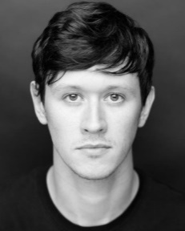
Stephen Lloyd is Artistic Director of Amplified Theatre, an inclusive theatre company that focuses on merging live theatre with alternative music genres. His theatre credits include: Henry V (UK Tour), The Deranged Marriage (Watford Palace/West Yorkshire Playhouse/Rifco Arts), Reasons To Be Cheerful (UK Tour/Graeae/New Wolsey/Theatre Royal, Stratford East),, Come Dancing, Red Riding Hood and Cinderella (Theatre Royal, Stratford East) Film and TV credits include: Boycie in Rock and Chips, Holby City, Silent Witness, Gracie! (BBC), Paralympics Opening Ceremony (Channel 4), Seat 25 (Red Kite Films).

Stephen Collins - COLIN
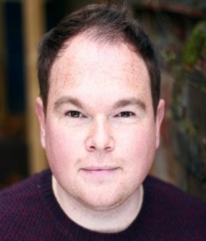
Stephen Collins is an actor, workshop facilitator and recently debut as a director & Associate Artist for Amplified Theatre. His theatre credits include Summit (Fuel Theatre), Nodus Tollens (DH Ensemble), The Government Inspector (Ramps on the Moon/Birmingham Rep), Threeepenny Opera, The Iron Man (Graeae), Shakespeare Globe's Love's Labour's Lost & Red Flags (Deafinitely Theatre), Hansel & Gretel (Red Earth) & The Winter's Tale (Taking Flight).
Beth Hinton-Lever - JANINE
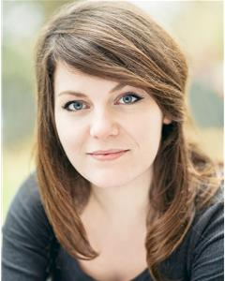
Beth Hinton-Lever has recently graduated from Mountview Academy of Theatre Arts with an MA in Performance (Musical Theatre). Her choreography of Jason Robert Brown's Parade won her the Award for Best Choreography at the National Student Drama Festival, which started her professional performing career. Credits include: Mona/Georgina in Dancehall (CAST Theatre), Princess Aurora/Rosie in Sleeping Beauty (CAST Theatre), and Clara in Welfare (Arts Theatre).

Gerard McDermott - BILL / BOBBY
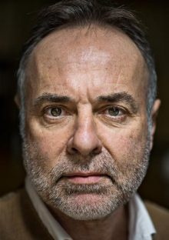
Gerard McDermott’s recent theatre credits include; Merry Wives (Northern Broadsides), Blood Wedding (Graeae), Bunny’s Vendetta (Blue Eagle), Being Tommy Cooper (The Old Red Lion), Fool for Love (The Riverside Studios) and Calendar Girls (Tour/Noel Coward Theatre). For Graeae he has appeared in Blasted (Northern Broadsides). Television and film credits include; Doctors, EastEnders, Downton Abbey (BBC), and Eyes and Prize (2017).

Karen Spicer – PAT
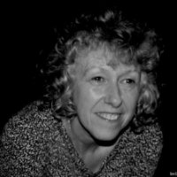
Karen Spicer has played a variety of roles on screen in Coronation Street (ITV), Emmerdale (ITV), Doctors (BBC) and Clocking off (Channel 4).On stage she has worked with Graeae, Trestle, Red Ladder, Theatre Centre, Roundabout, Quick Silver, Fittings Multimedia, The Nuffield Theatre Southampton, Interplay, and Polka.

Joey Hickman - UNCLE HARRY (MD)
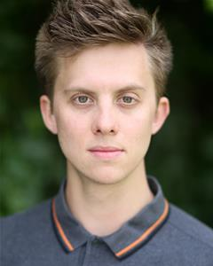
Joey Hickman Joey Hickman (Uncle Harry) trained as a musical director his MD, assistant MD, band leader & arranger credits include: The Comedy About A Bank Robbery (Mischief Theatre & Criterion Theatre, Piccadilly Circus); Oliver! (Watermill Theatre); Three Minute Heroes (Belgrade Theatre); The Threepenny Opera (Graeae Theatre/UK Tour); Our House (New Wolsey Theatre/UK Tour); Dreamboats and Petticoats (BKL Playhouse Theatre, West End) and Assassins (Rose Bruford). As an actor, Joey has performed in many productions across the country including: Thisbe (Door Ajar Theatre); Cinderella: A Fairytale (Tobacco Factory & Traveling Light) and Made In Dagenham (Queen's Theatre).
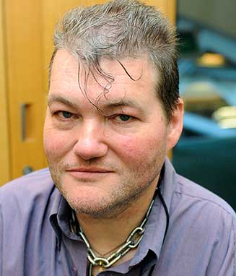
John Kelly - JOHN (LEAD VOCALS)
John Kelly has completed five UK tours as well as many international performances. John is Artistic Director of DaisyFest, National Associate Artist for Drake Music, musician with circus company ExtraOrdinary Bodies and is Policy & Strategy manager at Merton Centre For Independent Living. John sang Spasticus Autisticus, live at the opening ceremony of the Paralympic Games in London, and has also guested with the Blockheads.

Paul Sirett - PAUL (GUITAR)
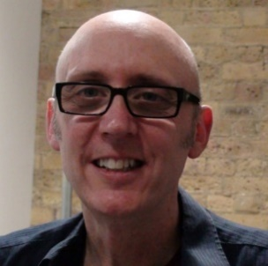
Paul Sirett is a playwright, dramaturg and musician. He is currently working as the dramaturg on the new Ramps on the Moon production of The Who’s rock opera Tommy – a job that includes integrating two new songs from Pete Townshend and revising the script to make the production fully accessible. Most recently, Paul wrote Stratford East’s biggest ever selling pantomime, Simbad The Sailor, and worked as the dramaturg on a re-working of the John Mellencamp and Stephen King musical, Ghost Brothers Of Darkland County in New York. Previously, Paul was nominated for an Olivier for his musical The Big Life and he wrote Come Dancing with Ray Davies. Upcoming productions include a new Punk Rock musical, Oxy and the Morons, at the New Wolsey in Ipswich, and a new Graeae tour of Paul’s Ian Dury and the Blockhead’s musical Reasons To Be Cheerful.
Nixon Rosembert - NIXON (BASS)
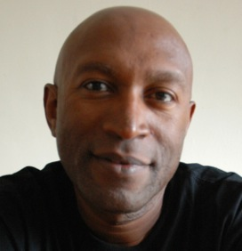
Nixon Rosembert is an accomplished musician who has performed/recorded either in the recording studio, on television, or live with Mariah Carey, Ronnie Laws (EWF), Angie Brown, Pete Brown, Reasons To Be Cheerful (band), The Honeyz, Sam Moore (Sam & Dave), Ruby Turner, Jools Holland, Juliet Roberts, Billy Paul, ABC, Cleveland Watkiss, Emmett North Jnr, Clem Curtis & The Foundations and many more. He has written music for theatre and toured with theatre companies as a musician and actor.

Paula Faircloth - PAULA (DRUMS)
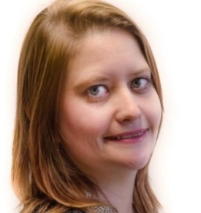
Paula Stanbridge-Faircloth has been playing the drums for over two decades. Faircloth has performed at intricate math-rock polyrhythms in Quadrilles, the opening ceremony of the Paralympic Games, toured with Reasons to be Cheerful and Psycho Delia, in addition to forming a Kate Bush tribute band.

Max Runham - MAX (PERCUSSION)
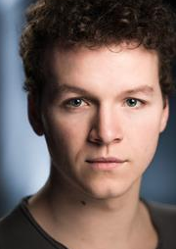
Max Runham has appeared in Graeae's production of The Threepenny Opera, The Funfair (HOME), The Family Way (Bolton Octagon), Gods are fallen and all safety gone (Camden People’s Theatre) and most recently, Max made his debut with The National Theatre and Complicite in A Pacifist's Guide to The War on Cancer. Max has recently played the role of Captain Walker in Ramps on the Moon's production of The Who's Tommy on national tour.

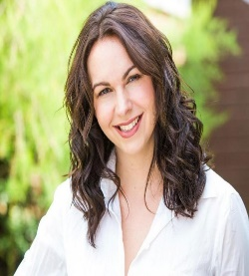
Jude Mahon - DEBBIE (SLI)
Jude Mahon trained as an Actor at Mountview Academy of Theatre Arts and as a British Sign Language Interpreter at Wolverhampton University. These two skills have worked together in numerous roles on television and in theatre. As a Performance Interpreter Jude won The Best Supporting Actress award from Nottingham Playhouse for her role in Graeae’s The Threepenny Opera.

Pickles Norman - PICKLES (AD)
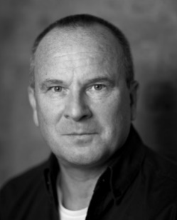
Wayne ‘Pickles’ Norman has been working professionally for forty years; his first job was the Artful Dodger in the West End production of Oliver! in 1977. Television credits include; Terry and June, Dr Who, Eastenders, Grange Hill, Inspector Morse and The Harry Enfield Show (BBC). Theatre work includes The Merry Wives of Waltham, Welcome Home, The Coming of Gowf, Afters and Counting the Ways. Pickles has been working for Graeae for 15 years as an access worker and also an audio describer appearing in their hit shows Reasons To Be Cheerful, The Iron Man and The Threepenny Opera.
CREATIVES: BIOGRAPHIES
About Graeae
Graeae is a force for change in world-class theatre - breaking down barriers, challenging preconceptions and boldly placing d/Deaf and disabled artists centre stage. Artistically led by Jenny Sealey, Graeae’s signature characteristic is the compelling creative integration of sign language, captioning and audio description, which engages brilliantly with both disabled and non-disabled audiences. Championing accessibility and providing a platform for new generations of artists, Graeae leads the way in pioneering, trail-blazing theatre. Graeae won the Promotion of Diversity Award at the TMA Theatre Awards UK 2012. Recent productions include: THE HOUSE OF BERNARDA ALBA (co-production with Royal Exchange Theatre), THE SOLID LIFE OF SUGAR WATER (co-production with Theatre Royal Plymouth), BLOOD WEDDING (co-production with Dundee Rep Ensemble and Derby Theatre), THE THREEPENNY OPERA (co-production with West Yorkshire Playhouse, New Wolsey Theatre Ipswich, Nottingham Playhouse Company and Birmingham Rep Theatre), BELONGING (co-production with Circo Crescer e Viver), REASONS TO BE CHEERFUL (originally co-production with New Wolsey Theatre Ipswich and Theatre Royal Stratford East), BLASTED and BENT. Spectacular outdoor productions include THE LIMBLESS KNIGHT (with Strange Fruit/ commissioned by GDIF), PROMETHEUS AWAKES (with La Fura dels Baus/co-commissioned by GDIF and SIRF) and THE IRON MAN. Also in 2017, Graeae will be returning to the Edinburgh Festival Fringe with COSMIC SCALLIES, a new play by award-winning writer Jackie Hagan, co-produced with the Royal Exchange Theatre.
www.graeae.org
https://twitter.com/graeae
Jenny Sealey MBE
Director / Artistic Director of Graeae
Jenny Sealey co-directed the London 2012 Paralympics Opening Ceremony alongside Bradley Hemmings (GDIF). She has been Artistic Director and CEO of Graeae since 1997 and has pioneered a new theatrical language, coining the term ‘aesthetics of access’. Credits for Graeae include THE HOUSE OF BERNARDA ALBA, BLOOD WEDDING, BLASTED, THE THREEPENNY OPERA, THE LIMBLESS KNIGHT, BELONGING and REASONS TO BE CHEERFUL. International work includes ROMEO AND JULIET in Bangladesh, BLOOD WEDDING in Tokyo and BELONGING in Brazil. Jenny was awarded her MBE in 2009 and The Human Rights Awards for the Arts in 2012.
https://twitter.com/GraeaeJennyS
Paul Sirett
Paul is a playwright, dramaturg and musician. He is currently working as the dramaturg on the new Ramps on the Moon production of The Who’s rock opera TOMMY – a job that includes integrating two new songs from Pete Townshend and revising the script to make the production fully accessible. Most recently, Paul wrote Stratford East’s biggest ever selling pantomime, SIMBAD THE SAILOR, and worked as the dramaturg on a re-working of the John Mellencamp and Stephen King musical, GHOST BROTHERS OF DARKLAND COUNTY in New York. Previously, Paul was nominated for a Olivier for his musical THE BIG LIFE and he wrote COME DANCING with Ray Davies. Upcoming productions include a new Punk Rock musical, OXY AND THE MORONS, at the New Wolsey in Ipswich, and a new Graeae tour of Paul’s Ian Dury and the Blockhead’s musical REASONS TO BE CHEERFUL.

SYNOPSIS
A coming of age tale that rejoices in the infectious and enduring music of Ian Dury and the Blockheads. Featuring stone-cold classic songs including Hit Me With Your Rhythm Stick; Plaistow Patricia; Sex and Drugs and Rock and Roll; Sweet Gene Vincent; What A Waste and the titular Reasons to be Cheerful (Part 3), this show is loud, bold and jubilant.

The parallels with the show’s 1979 setting are clear. Today, as nationwide cuts continue to impact on the lives of d/Deaf and disabled people, Graeae Theatre Company puts them centre stage. As a prominent disabled activist, Ian Dury was a patron and staunch supporter of Graeae. The extraordinary wit and wisdom of Ian Dury and the Blockheads music and lyrics are brought to life by an inclusive cast of 15 actors and musicians.

It is 1979. Labour has just lost the General Election to the Tories. Strikes rock the nation and Ian Dury and the Blockheads’ Reasons to be Cheerful (Part 3) is climbing the charts. Die-hard fans Vinnie and Colin are on a mission to see Ian Dury and the Blockheads play Hammersmith Odeon. With no tickets to a sold-out gig their journey throws more at them than they could have ever expected….

Using Graeae’s signature theatrical language, all performances of Reasons to be Cheerful seamlessly include British Sign Language, audio description and creative captioning.

CHARACTERS
Vinnie
Vinnie is the lead character and narrator, son of Pat and Bobby and best friend of Colin. In the hope of cheering up his family, Vinnie is determined to take Colin and his dad, Bobby to the Ian Dury concert, at the same time as impressing his love interest, Janine.

Colin
Colin is Vinnie’s best friend and band mate. Like Vinnie, Colin is a massive Ian Dury fan and desperate to go to the concert to see his idol. Always keen to wind up boss, Dave, and help Vinnie win Janine’s heart, Colin helps Janine steal Dave’s concert tickets.

Janine
Janine is Vinnie’s co-worker and love interest. She was dating Vinnie’s boss Dave before he cheated on her and as revenge, Janine steals one of Dave’s tickets to Ian Dury and the Blockheads and takes the rest of them to the concert with Vinnie, Colin and Bobby. Throughout the performance Janine sings backing vocals.

Pat
Pat is Vinnie’s mother. She was the full-time carer for husband/Vinnie’s dad Bobby while he was ill with cancer. Constantly worried about Bobby’s illness, Vinnie’s education and their financial situation, Pat, is tries her best to do the right thing by her family.

Bill/Bobby
Bill is the best friend of Vinnie’s dads from the National Union of General and Municipal Workers. During the show, he plays the part of Bobby, Vinnie’s dad. Bobby is ill with cancer and is looked after by his wife, Pat. Frustrated with his illness and society, Bobby is determined to protect and look after his family.

Nick/Dave
Nick is a friend of Vinnie’s from college, he is lead saxophonist. During the show, Nick plays the role of Dave who is Vinnie’s old boss from Fine Fare. Dave is desperate to be in Vinnie’s band

Uncle Harry
Vinnie’s uncle and keyboardist in the band in the band, who perform all the music live on stage.

John
John is the lead vocalist of the band who play live on stage.

Nixon
A work friend of Vinnie’s dad. He is the bassist for the band who plays live on stage.

Paul
Paul is the lead guitarist for the band who plays along-side Nixon, Paula, Uncle Harry and Daniel.

Paula
Paul is the drummer for the band who plays along-side Nixon, Paul, Uncle Harry and Daniel liv on stage.

Debbie
Debbie is a friend of Colin who choreographed the dancing for the story. She is the BSL interpreter throughout the show.

Pickes
Pickles is a friend of Vinnie’s who is behind the audio description for the performance.

PROTEST SONG CAMPAIGN

Combined with the show, we’re also inviting members of the local community to write and record their own protest songs, the best of which we’ll take on tour with us. All of the entries will also go onto Graeae’s website as recordings/lyric videos. Songs can be written and recorded in any format accessible to the writer. More information on this can be found at www.graeae.org/protest-song

We want this Protest Song campaign to be integrated into the marketing for the show, so that whenever the show is talked about, this Protest Song campaign is also referenced, and members of the public know they can write and submit their own song.

CONTEXT AND HISTORY
Ian Dury was a cult punk icon in the 1970s, born in 1942 in Harrow on the Hill. He was also disabled.
At 22 he studied at the Royal College of Art under Peter Blake and met his future bandmates. Following the death of rock n roll star Gene Vincent in 1971, Dury started his first band ‘Kilburn and the High Roads’. The band joined the gig circuit and played together for 5 years with their final gig in 1976, supported by The Stranglers and the Sex Pistols. At around the same time Ian met Chaz Jankel, the pair would go on to write some of The Blockheads’ biggest hits.
The seminal album New Boots and Panties came out on 30th September 1977 (40 years ago this year) and sold 1,000,000 copies. The Blockheads were created as Ian’s band for the UK tour of the album. Together they released hit records such as ‘Hit me with your Rhythm Stick’ (1978), ‘Reasons to be Cheerful, Part 3.’ (1979), ‘I Want to be Straight’ (1980). Perhaps the most controversial moment of the band’s career was in 1981, the UN designated ‘Year of the Disabled’, in reaction to this Dury and Chaz wrote an anti-charity anthem ‘Spasticus Autisticus’. The BBC deemed the lyrics to be too offensive to be aired so it received a network-wide ban. In 2012 Graeae performed the song as part of the opening ceremony to the Paralympics, broadcast to millions on the BBC.
The band regularly disbanded to pursue solo careers and intermittently released new material and toured with a flexible line up right up until February 6th 2000 when they played their final gig at the London Palladium. Ian died on 27th March 2000.
The Blockheads continue to tour together and this year are marking the 40th anniversary of their formation.
1979 Britain
Reasons to be Cheerful is set in 1979. 1979 is a landmark year in British political history; Margaret Thatcher became Prime Minister, taking over from the incumbent Labour government. Her appointment was followed by nearly a decade of strikes, blackouts and severe unemployment.
Young people’s voices weren’t being heard, they were the post-war generation, being told they didn’t know how good they had it, whilst struggling with a complete lack of jobs, cuts to benefits and a increasingly conservative government. In a backlash to the current establishment, punk boomed. Whilst Sex Pistols suffered the loss of Sid Vicious, Ian Dury and the Blockheads already had a cult following, Hit me with your Rhythm Stick came out in 1979 alongside the release of The Clash’s London Calling, Joy Division’s Unknown Pleasures, The Undertones’ first album and The Damned’s Machine Gun Etiquette.

PRESS ANGLES AND IDEAS
In additional to traditional interviews with the cast and creative team in local print, online and broadcast outlets, below is a non-exhaustive list of some press angles and ideas for Graeae’s Reasons to be Cheerful that might feed in to your own campaign for the show.

We really want to promote the fun and boisterous energy of this production so encourage you to share any additional ideas that might work for your media.

- Music takeover on a local radio programme
  - Reason to be Cheerful radio phone-in. Contact local radio stations to see if they would be interested in having a phone-in where listeners could call in with their reasons to be cheerful in 2017 or providing song that makes them ‘cheerful’ along with their reason why.
  - Alternatively, this would be a good opportunity to reach out to any local radio shows who focus on 70s music; The Clash, Ramones, The Stranglers, Blondie etc. Would they be interested in a Blockheads/British punk take over? The radio station could ask listeners share their own memories of the 70s. With the new song being written by Derek Hussy & Chaz Jankel, it could be the perfect opportunity to plug Reasons to be Cheerful so fans can hear it.
  - Would a local online outlet take a ‘playlist to get you in the mood for Reasons to be Cheerful’? Perhaps we could get the cast or the Blockheads to put this together and host on Spotify so it’s easily shareable. Or you could create this and invite people to add their own suggestions via social media
- Historical/Political opinion piece
  - Reach out to any local press that might be interested in writing a historical/political piece about the comparison of the cuts between the late 70’s and now mixed with weaving in the story of the relationship that the Blockheads have with the RTBC show, the cast and Graeae.
  - Alternatively, if there is a local journalist who is a fan of 70s punk music and who might be interested in writing a piece on Ian Dury and the Blockheads activism and lasting legacy.
  - Reach out to a local music journalist or publication to see if they would be interested in writing a piece about Music and arts and social commentary – including how Graeae use their work to promote social change and start discussion e.g. from Billy Bragg to Pussy Riot to Beyoncé to the protest songs the public are being encourage write

- Focus piece on Graeae
  - Have Graeae visited your venue or area before? How was the audience reaction? Profile piece on the innovative approach of Graeae. Using their signature theatrical language, all performances of Reasons to be Cheerful seamlessly include British Sign Language, audio description and creative captioning.
  - Pitch to local TV stations a feature on learning sign language, could you reach out to local BSL schools to help with this? Could feature a presenter being taught how to sign one of the songs from the show.
- Interview features with key cast and creatives
  - Profile pieces or combing interviews with:
    - Jenny Sealey – Director of Reasons to be Cheerful and the Artistic Director of Graeae
    - Paul Sirett – Olivier-nominated and multi-award-winning playwright, dramaturg and musician, who wrote Reasons to be Cheerful: Part 3.
    - Liz Ascroft – Reach out to relevant local press about the fashion of the 70s, would they be interested in speaking to Liz Ascroft about her inspirations for the show; Top 5 fashion icons of the 70s or Top 5 70s fashion pieces.
    - Blockheads; Derek Hussey or Chaz Jankel. There will be a new, original song written by Chaz Jankel, Derek Hussey (original Blockheads members) and John Kelly for the 2018 tour which will be performed as an ‘encore’ at the end of the show. Plug with local press as the first and only chance to hear this brand-new song.
    - Jemima Dury – The daughter of Ian Dury’s daughter and huge fan of the show. Jemima would be available for any syndicated Q&A for local press.
    - Sir Peter Blake – World renowned artist and Graeae patron, who designed a limited-edition poster for the show on previous tour using the Reasons to be Cheerful: Part 3 lyrics.
    - Cast Q&A’s
      - Stephen Lloyd, Stephen Collins, Karen Spicer, Wayne ‘Pickles’ Norman, Jude Mahon were key roles in the previous tour. Approach any local press who might be interested in speaking to them about how they have found returning to their roles, what it is like to work with Jenny and Graeae again. Also, how the production is still relevant today as nationwide cuts continue to impact on the lives of d/Deaf and disabled people.
      - Beth Hinton-Lever, Gerard McDermott, Joey Hickman and Max Runham will be joining the Reasons to be Cheerful cast for the upcoming tour. Reach out to local press for Q&A style piece about how they have found joining the cast, what it has been like to work with Jenny and Graeae and about the show.
- Blockheads 40th anniversary this year
  - This year will make the 40th anniversary of The Blockheads.
  - There will be a documentary ‘Beyond the call of Dury’ with album released this year, as TX dates and more details are confirmed, we’ll share info and see how we can maximise this.

- Disability Press
  - As the show is performed by an integrated cast of D/deaf and disabled artists, as well as non-disabled artists, and all performances feature creative British Sign Language, audio description and captioning, any of your local press or media covering disability will be interested in this production.
  - Graeae the UK’s leading disabled led theatre company, having been going for over 35 years, and having had recent productions at the National Theatre, Royal Exchange Theatre and Theatre Royal Plymouth.

- Reasons to be Cheerful press
  - Many of the cast members in the 2017 tour performed an excerpt from the show (Spasticus Autisticus) at the opening ceremony of the London 2012 Paralympic Games, in front of HM The Queen
  - Although having toured in various guises in the UK and around the world since 2010, this is the last time this show will be seen,

TOUR DATES AND VENUES

Friday 8 & Saturday 9 September
Belgrade Theatre Coventry
http://www.belgrade.co.uk/
024 7655 3055
Tuesday 12 – Saturday 16 September
Derby Theatre
https://www.derbytheatre.co.uk/
01332 59 39 39
Tuesday 26 – Saturday 30 September
Nuffield Theatre, Southampton
https://www.nstheatres.co.uk/
023 8067 1771
Tuesday 3 – Saturday 7 October
New Wolsey Theatre, Ipswich
https://www.wolseytheatre.co.uk/
01473 295900
Tuesday 10 – Saturday 14 October
West Yorkshire Playhouse, Leeds
https://www.wyp.org.uk/
0113 213 7700
Tuesday 17 – Saturday 21 October
Liverpool Everyman
https://www.everymanplayhouse.com/
0151 709 4776
Tuesday 24 October – Saturday 4 November
Theatre Royal Stratford East
http://www.stratfordeast.com/
020 8534 0310

SOCIAL MEDIA
https://www.facebook.com/R2BCheerful/
@R2BCheerful / #Reasonstobecheerful

https://www.youtube.com/user/GraeaeTheatreCompany

PRESS RESOURCES
- EPK is available upon request for TV opportunities and online syndication
- Set up images and production shots can be downloaded from The Corner Shop website
FOR PRODUCTION IMAGES THE CORNER SHOP DOWNLOAD SITE CAN BE ACCESSED HERE

TRAILER

The generic tour trailer can be seen and downloaded at: https://vimeo.com/217014732

Venue specific trailers – To be supplied separately to your marketing teams.

AUDIO FLYER

This is for the purposes of blind/visually impaired audience members to access information about the show, including the audio description and other accessible features that will be of interest to this audience:

Full tour : https://soundcloud.com/graeaetheatre/audio-flyer-reasons-to-be-cheerful
Belgrade Coventry: https://soundcloud.com/graeaetheatre/reasons-to-be-cheerful-belgrade-theatre-coventry-audio-flyer
Derby Theatre: https://soundcloud.com/graeaetheatre/reasons-to-be-cheerful-derby-theatre-audio-flyer
Nuffield Southampton: https://soundcloud.com/graeaetheatre/reasons-to-be-cheerful-nuffield-theatre-southampton-audio-flyer
New Wolsey Theatre, Ipswich: https://soundcloud.com/graeaetheatre/reasons-to-be-cheerful-new-wolsey-theatre-ipswich-audio-flyer
West Yorkshire Playhouse: https://soundcloud.com/graeaetheatre/reasons-to-be-cheerful-west-yorkshire-playhouse-audio-flyer
Liverpool Everyman: https://soundcloud.com/graeaetheatre/reasons-to-be-cheerful-liverpool-everyman-audio-flyer
Theatre Royal Stratford East: https://soundcloud.com/graeaetheatre/reasons-to-be-cheerful-theatre-royal-stratford-east-audio-flyer

BSL VIDEO FLYER:
This is for the purpose of Deaf audiences to access information about the production.

This can be viewed and downloaded at: https://vimeo.com/220327496

Embed code for websites:
<iframe src="https://player.vimeo.com/video/220327496" width="640" height="360" frameborder="0" webkitallowfullscreen mozallowfullscreen allowfullscreen></iframe> <p><a href="https://vimeo.com/220327496">BSL introduction &amp; synopsis - Reasons to be Cheerful 2017</a> from <a href="https://vimeo.com/user11948864">Graeae</a> on <a href="https://vimeo.com">Vimeo</a>.</p>

ACCESS INFORMATION
All performances include creative British Sign Language, audio description and captioning.

Please contact Richard Matthews on richard@graeae.org or call 020 7613 6906 if you would like this press release in alternative forms.

Various resources, including access logos, can be downloaded from http://graeae.org/about/resources/

GRAEAE MEDIA LANGUAGE GUIDE
As Graeae are a disabled-led theatre company, many articles or interviews are likely to refer to disability in some way, shape or form. There are two basic things that we believe are good to bear in mind: is the reference relevant to the article? Is the language appropriate?
Under the social model of disability, people are disabled by barriers within society, rather than being ‘victims’ of their impairments or conditions.
You can help increase public awareness by using the correct language, and approaching your story from the social model perspective.
Basic language guide
Yes | No
disabled | handicapped, cripple, invalid
disabled people | the disabled, people with disabilities
has ... (an impairment) | suffers from..., victim of ...
non-disabled | able bodied, normal, healthy
learning disabled | mentally disabled, retarded, backward
wheelchair user | wheelchair bound, confined to a wheelchair, in a wheelchair
Deaf | the deaf
Deaf sign language user, BSL user | deaf and dumb, deaf mute
blind or partially sighted people, visually impaired people (VIP) | the blind
mental health service user / survivor | mentally ill, insane, mad, crazy
has cerebral palsy | spastic
person of short stature | dwarf, midget
For further information see The NUJ and Disability Now guide, Hacked Off: www.scope.org.uk/sites/default/files/pdfs/Campaigns_policy/DN_hacked_off_guide.pdf
Graeae’s Access Essentials Guide, which is a really useful easy to read guide covering the essentials on welcoming D/deaf and disabled audiences to your venue, can be downloaded from http://graeae.org/wp-content/uploads/2017/05/Graeae-access-essentials-A5-highres-with-hole-guides.pdf

PRESS RELEASES

GRAEAE’S CULT HIT MUSICAL REASONS TO BE CHEERFUL TO EMBARK ON UK TOUR FROM SEPTEMBER 2017
- Part gig, part play, Reasons to be Cheerful celebrates the infectious music of Ian Dury and the Blockheads in this bold and jubilant coming of age tale
- Fully accessible punk production is directed by Jenny Sealey MBE, Artistic Director of Graeae, and written by Paul Sirett
- Coinciding with the 40th anniversary of Ian Dury and the Blockheads’ seminal album ‘New Boots and Panties!!’, the musical features a catalogue of the band’s hits
- Images from previous production available here (Username: Graeae Password: Blockheads)
The pioneering disabled-led theatre company Graeae has confirmed tour dates and venues for the return of their acclaimed musical Reasons to be Cheerful, which will hit the road this autumn. Following a hugely successful tour in 2012 which was seen by almost 12,000 people and a series of concert performances last year, this joyful and defiant production will visit seven regions around the country, kicking off at the Belgrade, Coventry on 4 September and rounding off the tour with a two week run at Theatre Royal, Stratford East in London.
First seen in 2010, Reasons to be Cheerful has gone onto play at theatres and festivals across the UK, in stadiums around the world, and even in front of HM The Queen. “Spasticus Autisticus”, the Ian Dury-penned disability rights anthem which features in the show, was performed by the cast at the London 2012 Paralympic Games Opening Ceremony and, despite being banned by the BBC in 1981, broadcast worldwide in front of an audience of over 1 billion.
This coming of age tale rejoices in the infectious and enduring music of Ian Dury and the Blockheads. Featuring stone-cold classic songs including Hit Me With Your Rhythm Stick; Plaistow Patricia; Sex and Drugs and Rock and Roll; Sweet Gene Vincent; What A Waste and the titular Reasons to be Cheerful (Part 3), this show is loud, bold and jubilant.
The parallels with the show’s 1979 setting are clear. Today, as nationwide cuts continue to impact on the lives of d/Deaf and disabled people, Graeae Theatre Company puts them centre stage. As a prominent disabled activist, Ian Dury was a patron and staunch supporter of Graeae. The extraordinary wit and wisdom of Ian Dury and the Blockheads music and lyrics are brought to life by an inclusive cast of 15 actors and musicians.
It is 1979. Labour has just lost the General Election to the Tories. Strikes rock the nation and Ian Dury and the Blockheads’ Reasons to be Cheerful (Part 3) is climbing the charts. Die-hard fans Vinnie and Colin are on a mission to see Ian Dury and the Blockheads play Hammersmith Odeon. With no tickets to a sold-out gig their journey throws more at them than they could have ever expected….
Using Graeae’s signature theatrical language, all performances of Reasons to be Cheerful seamlessly include British Sign Language, audio description and creative captioning.
Jenny Sealey, Director of Reasons to be Cheerful and Artistic Director at Graeae Theatre Company, said: ‘I am beyond thrilled that our Reasons to be Cheerful gang are dusting off their Dr. Martens and going back out on the road one final time in a new production of our hit show, thanks to support from Arts Council England's Strategic Touring Fund. We will be well and truly raising the roof up and down the country with the brilliantly anarchic music of Ian Dury and the Blockheads, whose punk sentiment speaks louder than ever as we fight against the brutal cuts that Deaf and disabled people, and millions of others, have faced in recent years.’
Jemima Dury, daughter of Ian Dury, said; ‘I’m so excited for everyone who will see Reasons to Be Cheerful on this 2017 tour. You are in for a treat! It’s energizing, it’s moving and it’s enormous fun. It comes as close as you can get to a 1979 Ian Dury and the Blockheads gig. Graeae gives us diverse, accessible theatre at its best. This is how all theatre should be!’
Chaz Jankel, original Blockhead and co-writer of many songs in the show, said; 'It is amazing to think that 37 years after Ian and I wrote Reasons to be Cheerful (Part 3), the song still has such an impact and sounds so fresh. The Blockheads still perform it at every gig and the vibe in the audience and on stage definitely goes up a couple of notches as we lock in our reasons to be cheerful groove! The Graeae production has added a whole new lease of life to the song and legacy of Ian Dury. The extraordinary energy and skill that the cast bring to this original musical production is edgy yet heartwarming and mesmerising. The respect they have for Ian’s lyrics and lust for life is undeniable. If Ian were alive I am sure he would be laughing his head off and applauding the bravura of this very talented ensemble.'
An extensive community engagement programme will take place alongside this production, inviting original protest songs for a generation to be included in the show’s tour. For further information, email jodi@graeae.org
Reasons to be Cheerful was first performed in autumn 2010 with original co-producers New Wolsey Theatre, Ipswich and Theatre Royal Stratford East.
This tour is supported by Arts Council England through their Strategic Touring Fund.
Twitter:@R2BCheerful
#Reasonstobecheerful
Facebook: Reasons to be Cheerful – the Musical
YouTube: GraeaeTheatreCompany

Graeae’s media language guide can be viewed here
- ENDS -
For further information please contact Philippa Redfern philippa@thecornershoppr.com // 02078317657
If you would like this information in a different format please contact helen@graeae.org

OTHER USEFUL CONTACTS

Marketing:
Pam Kehoe
Jane Morgan Associates
pam@janemorganassociates.com
020 7263 9867
Graeae:

Marketing:
Richard Matthews
Head of Marketing and Development
richard@graeae.org
020 7613 6906
Creative Learning: (Protest Song campaign)
Jodi-Alissa Bickerton
Creative Learning Director
jodi@graeae.org
020 7613 6900
Access:
Helen Jackson-Lyall
Access Manager
helen@graeae.org
020 7613 6900.

